

**CENTRAL UNIVERSITY SIERRA LEONE**

**1 SILICON HILL, MILE 91**

FACULTY OF SCIENCE AND TECHNOLOGY

**DEPARTMENT:** TECHNICAL SCIENCE

**PROGRAM:** COMPUTER SCIENCE

**INTEGRATED RELIGIOUS MANAGEMENT PORTAL**

**BY**

**SAMUEL DOMINIC KAMARA**

**ID:** 2021167

A DISSERTATION SUBMITTED IN PARTIAL FULFILMENT OF THE REQUIREMENTS FOR THE AWARD OF BACHELOR OF SCIENCE (HONS) IN COMPUTER SCIENCE

**Submitted On:** January 27, 2025

**Supervised by:** Mr David Sapunka Fornah

**DECLARATION**

I hereby declare that the project titled, Integrated Religious Management Portal, (IRMP), is my original work and has not been submitted previously for any degree or diploma at any institution. Any references or materials used in the preparation of this project report have been appropriately cited and acknowledged. I affirm that this project has been conducted in compliance with the academic and ethical standards of Central University.

**CERTIFICATION**

This is to certify that, the Integrated Religious Management Portal, (IRMP), has been acknowledged by the Faculty of Science and Technology at Central University. This work represents a comprehensive research effort on the chosen topic and has been successfully presented, fulfilling the academic requirements for the degree to which it has been submitted.

**Signature:** ……………………………………………………………………………………..

Mr. David Sapunka Fornah Supervisor

**Signature:** ……………………………………………………………………………………..

Isaac Muckson Sesay Dean of faculty

**TABLE OF CONTENTS**

**DECLARATION**…………………………………………………………………….……2

**CERTIFICATION**…………………………………………………………….………….3

**TABLE OF CONTENTS**…………………………………………………….……….......4

**LIST OF ACRONYMS**………………………………………………….………………..8

**LIST OF FIGURES**……………………………………………………….………………9

**ACKNOWLEDGEMENT**……………………………………………….……………….10

**ABSTRACT**……………………………………………………………………………….11

**CHAPTER ONE**

**1.1 INTRODUCTION**…………………………………………………………………….12

**1.2 BACKGROUND**………………………………………………………………….......13

**1.3 PROBLEM STATEMENT**…………………………………………………………..14

**1.4 JUSTIFICATION OF THE STUDY**………………………………………………...14

**1.5 AIMS AND OBJECTIVES**…………………………………………………………..15

1.5.1 Aim…………………………………………………………………………..15

1.5.2 Objectives……………………………………………………………………15

**1.6 RESEARCH QUESTIONS**…………………………………………………………..15

**1.7 SCOPE & LIMITATIONS**…………………………………………………………..15

1.6.1 Scope of the Study……………………………………………………………15

1.6.2 Limitations…………………………………………………………………...16

**1.8 SIGNIFICANCE OF THE STUDY………………………………………………….16**

**CHAPTER DEMARCATION**…………………………………………………………...18

**CHAPTER TWO**

**2.1 OVERVIEW OF THE STUDY**………………………………………………….......19

**2.2 THEORITICAL FRAMEWORK**…………………………………………………...19

**2.3 TECHNOLOGICAL INTEGRATION IN RELIGIOUS ORGANISATIONS**…..20

**2.4 ADMINISTRATIVE FUNCTION OPTIMISATION**……………………………..20

**2.5 REVIEW OF RESEARCH OBJECTIVES**…………………………………………21

**2.6 RESEARCH GAPS**…………………………………………………………………...22

**2.7 SUMMARY**……………………………………………………………………………23

**CHAPTER THREE**

**3.1 RESEARCH DESIGN**……………………………………………………………………..24

3.1.1 Agile Methodology…………………………………………………………..24

**3.2.1 Why Agile Methodology…………………………………………………….25**

**3.1.3 Advantages of Agile Methodology…………………………………………..25**

**3.1.4 Challenges of Agile Methodology…………………………………………...25**

**3.1.5 Phases of the Agile Model…………………………………………………...25**

**3.2 REQUIREMENT GATHERING METHODS……………………………………...27**

**3.2.1 Importance of Requirement Gathering……………………………………….27**

**3.2.2 Methods Used for Requirement Gathering…………………………………..27**

**3.2.3 Limitations of the Methodology……………………………………………..28**

**3.3 SYSTEM ARCHITECTURE**……………………………………………………………..28

**3.3.1 Architectural Overview………………………………………………………28**

**3.3.2 System Components………………………………………………………….29**

**3.3.3 System Deployment………………………………………………………….29**

3.3.4 Overall System Design……………………………………………………….30

**3.4 ALGORITHM DESIGN…………………………………………………………………...30**

**3.5 USER INTERFACE DESIGN……………..................................................................31**

**3.6 DATABASE AND DATA MANAGEMENT DESIGN**……………………………..32

**3.6.1 Database Structure……………………………………………………………32**

**3.6.2 Data Management and Security………………………………………………33**

**3.7 SOFTWARE ENGINEERING PRACTICES**……………………………………….33

**3.8 SCALABILITY AND PERFORMANCE OPTIMISATION**………………………34

**3.9 SYSTEM DESIGN…………………………………………………………………….35**

4.9.1 Proposed System Architecture Design………………………………………..35

4.9.2 Advantages of this Architecture………………………………………………36

4.9.3 Use case diagram……………………………………………………………...37

4.9.4 The Entity-Relationship Model……………………………………………….37

4.9.5 ER Diagram…………………………………………………………………...39

4.9.6 Database Tables……………………………………………………………….39

4.9.7 Normalisation…………………………………………………………………41

4.9.7.1 Stages of Normalisation……………………………………………..41

4.9.8 User Interface Design………………………………………………………….41

**3.10 SECURITY DESIGN**…………………………………………………………………41

3.10.1 Activity Diagrams……………………………………………………………42

3.10.1.1 Admin Activities Diagram…………………………………………42

3.10.1.2 Affiliate Member (Sub-Admin) Activities Diagram……………….43

**3.11 DATA COLLECTION METHODS**…………………………………………………43

**3.12 DATA ANALYSIS PROCEDURES**…………………………………………………44

**3.13 ETHICAL CONSIDERATIONS…………………………………………………….44**

**3.14 LIMITATIONS**……………………………………………………………………….46

**CHAPTER FOUR**

**4.1 OVERVIEW…………………………………………………………………………..47**

**4.2 EXPLORATION AND INSTALLATION**……………………………………….….47

4.2.1 Exploration…………………………………………………………….……..47

**4.2.2 Installation………………………………………………………….………...48**

4.2.3 Server Setup and Configuration……………………………………………...48

4.2.4 Database Deployment………………………………………………………..48

4.2.5 Application Deployment……………………………………………………..48

4.2.6 System Testing and Debugging……………………………………………...48

4.2.7 User Access Configuration…………………………………………………..48  
**4.3 FULL SCALE IMPLEMENTATION AND SCALE-UP**…………………………..49

4.3.1 Full Scale Implementation……………………………………….…………...49

4.3.2 Scale-up……………………………………………………….……………...49

**4.4 SYSTEM TESTING AND SPECIFICATION……………………………………...50**

4.4.1 Development and Operating Environment…………………………………...50

4.4.2 Software and hardware requirements of the system………………………….50

4.4.3 Technologies Used……………………………………………………………51

4.4.3.1 Frontend Technologies……………………………………………...51

4.4.3.2 Backend Technologies……………………………………………...51

4.4.4 Development Tools…………………………………………………………...52

4.4.4.1 Testing Tools……………………………………………………….52

4.4.5 Module Implementation Interface……………………………………………52

4.4.5.1 IRMP Home Page…………………………………………………..52

4.4.5.2 IRMP Login Page…………………………………………………..53

4.4.5.3 Admin Dashboard………………………………..............................54

4.4.5.4 Affiliate Member Dashboard……………………………………….55

4.4.5.5 Event Management Page…………………………………………...55

4.4.5.6 Announcement Management Page…………………………………56

4.4.5.7 Add Affiliate Member Page………………………………………..57

**4.5 SYSTEM PERFORMANCE TEST AND USER TRAINING……………………..57**

**4.6 SYSTEM SECURITY AND MAINTENANCE……………………….…………….58**

**4.6.1 Physical and Virtual Security………………………………………………...58**

**4.6.2 Preventive, Corrective, Predictive…………………………………………....58**

**4.7 TECHNICAL ANALYSIS**…………………………………………………………...59

**CHAPTER FIVE**

**5.1 SUMMARY OF KEY FINDINGS OF THE RESULT**……………………………..60

**5.2 DISCUSSION OF FINDINGS**……………………………………………………….61

**5.3 COMPARISON WITH LITERATURE…………………………………………….62**

**5.4 PRACTICAL APPLICATIONS……………………………………………………..62**

**5.5 CONCLUSIONS DRAWN FROM THE RESEARCH**………...…………..............63

**5.6 RECOMMENDATIONS FOR FUTURE RESEARCH**……...…………………….63

**5.7 LESSONS LEARNED**………………………………………………………………..64

**5.8 FINAL THOUGHTS**…………………………………………………………………64

**References**………………………………………………………………………………....65

**APPENDIX – A**…………………………………………………………………………...66

**APPENDIX – B**…………………………………………………………………………...67

**APPENDIX – C**…………………………………………………………………………...71

**LIST OF ACRONYMS**

NF Normal Form

GB Gigabyte

AI Artificial Intelligence

API Application Programming Interface

CPU Central Processing Unit

CSS Cascading Style Sheets

CSV Computer System Validation

E-R Entity-Relationship

GHz Gigahertz

HTML Hypertext Mark-up Language

HTTPS Hypertext Transfer Protocol Secure

IDE Integrated Development Environment

iOS iPhone Operating System

IRC-SL Inter-Religious Council of Sierra Leone

IRMP Integrated Religious Management Portal

JS JavaScript

ORM Object Relational Mapping

OS Operating System

PDF Portable Document Format

RAM Random Access Memory

RDBMS Relational database management system

RQ Research Question

SDLC System Development Life Cycle

SEO Search Engine Optimisation

SMS Short Message Service

SQL Structured Query Language

SSG Static Site Generation

SSR Server-side Rendering

UAT User Acceptance Testing

UI User Interface

URIs Uniform Resource Identifier

URL Uniform Resource Locator

XSS Cross-Site Scripting

**LIST OF FIGURES**

Figure 1. Agile Methodology (Bydrec, Inc, 2023)…………………………………….........24

Figure 2. System Architecture………………………………………………………………36

Figure 3. Use case Diagram…………………………………………………………………37

Figure 4. ER Diagram………………………………………………………………….........39

Figure 5. Users Table………………………………………………………………………..40

Figure 6 Event Table………………………………………………………………………...40

Figure 7. Announcement Table……………………………………………………………...40

Figure 8. Admin Activities Diagram……………………………………………………...…42

Figure 9. Affiliate Member (Sub-Admin) Activities Diagram……………………..………..43

Figure 10. Software and hardware requirements of the system……………………………..50

Figure 11. Home page…………………………………………………………………..…...53

Figure 12. Affiliate Member Login…………………………………………………...……..53

Figure 13. Admin Dashboard………………………………………………………………..54

Figure 14. Affiliate member dashboard………………………………………………..........55

Figure 15. Add event………………………………………………………………………...56

Figure 16. Add announcement……………………………………………………………....56

Figure 17. Add Affiliate member…………………………………………………………....57

Figure 18. Source: D. S. Fornah (January 2017)…………………………………………....66

**ACKNOWLEDGEMENT**

I sincerely express my heartfelt gratitude to everyone who contributed to the successful completion of this dissertation and the development of my Integrated Religious Management Portal project.

First, I extend my deepest appreciation to my supervisor, David Sapunka Fornah, for his invaluable guidance, insightful feedback, and unwavering support throughout this research. His expertise and encouragement significantly shaped the direction and outcome of this project.

I am deeply thankful to my mother, who had long set the pace for my computer science journey, and I owe a debt of gratitude to my brothers for their constant encouragement, tolerance, and adequate support along this journey. Even during the most difficult part of the project, their confidence in my abilities kept me motivated.

I would also like to express my sincere thanks to my peers and colleagues, whose constructive feedback and thoughtful suggestions during the design, development, and testing phases helped enhance the system’s functionality and usability. Their collaboration and insights played a crucial role in defining key aspects of the project.

A special acknowledgment goes to the Inter-religious Council of Sierra Leone (IRCSL) for providing the inspiration and real-world context for this project. Their role in fostering religious harmony and administrative efficiency highlighted the need for a system like this, making this research both relevant and impactful.

I also appreciate the developer community and the wealth of online resources that assisted in overcoming technical challenges during development. Platforms such as Stack Overflow, Spring Boot documentation, Next.js resources, and MySQL guides were indispensable in navigating complex problems and improving the overall quality of the system.

I acknowledge the role of my educational institution, Central University Sierra Leone, for providing access to essential resources such as the Internet, and facilities such as the E-library, required to complete this project successfully. This project would not have been possible without the collective effort and support of all these individuals and organisations.

This work would not have been possible without the collective efforts, guidance, and support of all these individuals and organisations. I am truly grateful.

**ABSTRACT**

Religious institutions are essential to society, playing a central role in fostering community and providing spiritual guidance. To effectively manage their operations, these institutions require streamlined systems to handle administrative tasks and improve community engagement. This project presents the development of an **Integrated Religious Management Portal (IRMP)**, designed to optimise administrative workflows and enhance interaction within the religious community. The **Inter-religious Council of Sierra Leone (IRCSL)**, which works to promote national reconciliation, religious harmony, and health by uniting Christians and Muslims, faces significant challenges in managing member information and other administrative functions due to outdated manual systems. These traditional methods are prone to errors, inefficiencies, and security vulnerabilities, impeding the organisation's ability to store and access critical data and run its operations smoothly. This project introduces the creation and deployment of a digital **IRMP** specifically tailored to the needs of the IRCSL. The system is developed using **Spring Boot** for the backend, **Next.js** and **JavaScript** for the frontend, and **MySQL** for database management. This solution demonstrates how modern technologies can transform the management capabilities of religious institutions, offering improved efficiency, security, and community engagement.

Key Words: Integrated Religious Management Portal, Affiliate Member, Events, Announcements, Religious Organisation, Member Management, Event Coordination, Communication Platform, Node.js, Spring Boot, React, Angular, Tailwind CSS, Web Application, System Administration, User Engagement.

**CHAPTER ONE**

**1.1 INTRODUCTION**

Religious institutions play a crucial role in shaping cultural values, promoting unity, and addressing social and economic challenges. Established in 1997, the Inter-Religious Council of Sierra Leone (IRC-SL) exemplifies this responsibility by fostering interfaith collaboration and advocating for peace and reconciliation in the wake of the country’s civil war. Through various initiatives, including interfaith discussions, youth empowerment programs, and community education campaigns, the IRC-SL has significantly contributed to national unity and social stability. Despite these achievements, the IRC-SL faces operational difficulties due to its continued dependence on manual processes for membership management, event recording, and administrative coordination. These outdated methods lead to inefficiencies such as time delays, errors, and limited scalability, making it challenging for the organisation to operate effectively. In an era of rapid technological advancement, it is essential for institutions like the IRC-SL to leverage modern digital solutions to enhance efficiency and community engagement. This research proposes the development of an Integrated Religious Management Portal (IRMP) to address the operational needs of the IRC-SL. The system is designed to streamline administrative tasks, improve membership management, and offer a scalable solution that can evolve alongside the organisation's expanding activities.

The IRMP will incorporate cutting-edge technologies, including Spring Boot for backend development, Next.js and JavaScript for the front-end interface, and MySQL for database management. With features such as online member registration, event management, and secure data storage, the system aims to transform the IRC-SL into a more adaptive and responsive organisation, capable of meeting the demands of an increasingly connected and dynamic world.

**1.2 BACKGROUND OF THE STUDY**

The **Inter-Religious Council of Sierra Leone (IRC-SL)** has been a key institution in promoting **religious harmony, national unity, and social development** since its establishment in **1997**. Formed in the aftermath of the country’s devastating civil war, the IRC-SL played a crucial role in fostering peace by facilitating meaningful dialogue between **Christian and Muslim communities** (Portaankorva, 2015). The council's primary mission is to **strengthen interfaith cooperation, advocate for human rights, and support national integration**.

Through a network of **religious leaders**, including Christian clergy and Muslim imams, the IRC-SL has actively engaged in initiatives such as **sensitization campaigns, interfaith dialogues, and community education** on pressing social issues like **health crises, conflict resolution, and youth empowerment** (Conteh, 2011). These efforts have been instrumental in addressing key societal challenges. However, despite its important role, the IRC-SL continues to rely on **manual administrative processes**, including **paper-based membership records and event management**. These outdated methods often lead to **inefficiencies, inaccuracies, and delays**, making it difficult to access crucial data quickly, especially in emergency situations.

To address these challenges, this project proposes the development of an **Integrated Religious Management Portal (IRMP)**, which will enhance the efficiency of the IRC-SL’s operations. The system aims to **modernize administrative processes, connect members digitally, and optimise resource management**. Key features include **online member registration, profile management, and the ability to publicize IRC-SL events and projects**. The IRMP will enable the organisation to **accurately manage its membership database**, ensuring a **more structured and effective approach** to handling its activities.

Beyond improving immediate operational efficiency, the IRMP is designed to be a **scalable system**, capable of evolving alongside the IRC-SL’s growing needs. Future enhancements may include features for **donation management, tracking interfaith projects, regional coordination, and hosting virtual discussions**. By transitioning to a **modern digital platform**, the IRC-SL aligns itself with **global trends in organisational management and data security**, ensuring its continued relevance in an increasingly technology-driven world.

The successful implementation of the IRMP will position the IRC-SL as a **more adaptable and responsive organisation**, better equipped to fulfil its mission in a rapidly changing environment. By leveraging technology to **streamline operations and enhance engagement with its members**, the IRC-SL will not only expand its influence but also reinforce its role as a leading institution in **promoting interfaith harmony and national reconciliation** in Sierra Leone.

**1.3 PROBLEM STATEMENT**

The **Inter-Religious Council of Sierra Leone (IRC-SL)** plays a crucial role in promoting **peace and interfaith collaboration**. However, its operations are significantly hindered by the continued reliance on **manual administrative processes**. Key functions such as **membership management, event coordination, and data handling** are still carried out using paper-based methods, which are **inefficient, error-prone, and increasingly unsustainable** as the organisation grows. This outdated approach restricts the IRC-SL’s ability to **scale its operations, respond swiftly to crises, and effectively engage its diverse religious communities**.

The absence of an integrated **digital management system** prevents the IRC-SL from optimising its administrative processes or fully utilising its potential to address **critical social issues**, including **health crises, youth empowerment, and national reconciliation**. Additionally, the lack of a **centralised digital infrastructure** makes it difficult to maintain **accurate records, ensure data security, and facilitate seamless communication** among Christian and Muslim leaders within the organisation. These limitations **jeopardize** the IRC-SL’s ability to operate efficiently and fulfil its mission in an increasingly dynamic and technology-driven world.

**1.4 JUSTIFICATION OF THE STUDY**

The development and deployment of an **Integrated Religious Management Portal (IRMP)** is both essential and timely for the **Inter-Religious Council of Sierra Leone (IRC-SL)**. Given the organisation's vital role in **promoting social and religious harmony**, there is a pressing need for a **scalable and efficient** system to address its operational challenges and enhance engagement with its diverse stakeholders. The proposed IRMP will **streamline administrative processes** by automating key functions such as **member registration, event coordination, and communication**. This transition will **minimise errors, reduce administrative burden, and provide real-time insights** into organisational operations. Additionally, adopting a **digital platform** will **enhance data security, improve decision-making**, and expand outreach efforts within both **Christian and Muslim communities**.

This study is further supported by the **global shift toward digital transformation** within non-profit and interfaith organisations. The integration of technology has been proven to **increase efficiency, strengthen community engagement, and optimise resource management**.

Moreover, this research contributes to the broader **field of religious management systems** by presenting a **scalable and adaptable framework** that other interfaith organisations facing similar challenges can implement. With a focus on **user-friendliness, security, and future scalability**, the IRMP is designed to remain relevant and applicable beyond the context of Sierra Leone, offering a **model for other religious institutions** looking to modernize their administrative systems.

**1.5 AIM AND OBJECTIVES OF THE STUDY**

**1.5.1 Aim**

The goal of this project is to **design and create a centralised, scalable platform** that will effectively manage **membership data** for the **Inter-Religious Council of Sierra Leone (IRCSL)**, thereby enhancing the efficiency of membership management, event coordination, and communication, ultimately improving the organisation’s ability to foster interfaith collaboration and promote national unity.

**1.5.2 Objectives**

* To develop an **easy-to-use web application** that facilitates **member registration**.
* To ensure **secure storage and management** of members' information.
* To provide **up-to-date information** on upcoming **events and programs.**
* To design the system with the ability to **accommodate future enhancements** to streamline additional administrative tasks.

**1.6 RESEARCH QUESTIONS**

**RQ1:** In what ways can the IRMP enhance **member engagement** within the **IRC-SL**?

**RQ2:** What are the **limitations** of the IRC-SL’s current manual processes, and how can the **IRMP** address these issues?

**RQ3:** What are the **key features and functionalities** necessary for the **successful implementation** of the IRMP in the **IRC-SL**?

**RQ4:** How can the IRMP be designed to meet the **future needs** and **potential growth** of the IRC-SL?

**1.7 SCOPE AND LIMITATIONS**

**1.7.1 Scope of the Study**

This study focuses on the **membership management** component of the **Integrated Religious Management Portal (IRMP)** for the **Inter-Religious Council of Sierra Leone (IRC-SL)**. The system is designed to help **affiliated religious organisations** efficiently **register and manage** their members. The scope of the research includes the following key areas:

**Member Registration and Authentication**: Enabling **secure online registration** and login for both members and administrators.

**Event Management**: Allowing administrators to **create, update**, and **manage events**, and enabling members to **register** and **track participation** in these events.

**Communication Tools**: Providing a platform for **announcements, notifications**, and **communication** between administrators, religious leaders, and members.

**Data Security**: Ensuring the **secure storage** and management of sensitive member information, with **role-based access control** and **encryption** to protect data integrity.

**1.7.2 Limitations of the Study**

**Scope**: The study focuses on **membership management** within the **IRMP** and does not cover other potential features like donation tracking or regional operations.

**Technological Constraints**: The system is based on **Spring Boot, MySQL**, and **Next.js**, which could limit future adoption or scalability if different technologies are preferred.

**Internet Connectivity**: The system requires stable internet access for full functionality, which may be a limitation in areas with poor connectivity.

**User Adoption**: The system’s success depends on the **adoption** and **technical literacy** of the IRC-SL’s members and administrators.

**Data Security**: Although the system incorporates **encryption** and **role-based access**, future security risks cannot be completely eliminated.

**Resource Constraints**: **Time, budget**, and **human resources** may limit the extent of the research and development.

**Organisational Readiness**: The system assumes the IRC-SL is ready to adopt digital solutions, and any **resistance to change** could hinder successful implementation.

**1.8 SIGNIFICANCE OF THE STUDY**

This study is significant in its potential to **revolutionize the operational efficiency and community engagement** of the **Inter-Religious Council of Sierra Leone (IRC-SL)** through the development and implementation of an **Integrated Religious Management Portal (IRMP)**. The proposed system directly addresses critical weaknesses in the IRC-SL’s current administrative methods by automating **membership management, event coordination**, and **data storage**. This research is particularly valuable for the IRC-SL as it offers a **targeted solution** to enhance its ability to engage in **interfaith dialogue** and promote **peacebuilding**.

As an organisation focused on fostering **religious harmony** and **national unity**, the IRC-SL's ability to manage its growing network of members and stakeholders is vital. By adopting a **digital management system**, the IRC-SL can **scale its operations more effectively**, improve communication, and increase **engagement** across both **Christian and Muslim communities**. The IRMP will be critical to supporting the organisation’s growth and operational efficiency.

Moreover, this research is important for the IRC-SL’s long-term **success and influence** in shaping **Sierra Leone's religious landscape**. It contributes to the broader field of **religious management systems** by providing a **scalable framework** that improves administrative processes while fostering stronger **community engagement**. This approach can also serve as a model for other **religious and non-profit organisations** facing similar operational challenges.

**CHAPTER DEMARCATION**

This dissertation is organized into chapters, each covering a significant aspect of the **Integrated Religious Management Portal (IRMP)** development:

**Chapter One**: This introductory chapter provides the **background** of the study, outlines the **problem statement**, objectives, research questions, significance, and the scope of the study. It establishes the rationale for developing the system and specifies the goals it aims to achieve.

**Chapter Two**: This chapter reviews the **literature** relevant to the study. It explores the role of **technology in religious organisations**, the **optimisation of administrative tasks**, and how technology can enhance **community engagement**.

**Chapter Three**: This chapter details the **methodology** employed in the system’s development. It covers the methods used for **requirements gathering** and explains the **System Development Life Cycle (SDLC)** framework used to guide the project.

**Chapter Four**: This chapter focuses on **system analysis and design**. It describes the **functional** and **non-functional requirements** of the system, presents stakeholder and user roles, and includes various diagrams such as **use case diagrams, entity-relationship (ER) diagrams**, and **data flow diagrams**. Additionally, it provides details on **database design** and **system architecture**.

**Chapter Five**: This chapter outlines the **system implementation** and **testing** process. It covers the **setup of the development environment**, the **tools** and **technologies** used for both the backend and frontend, and the **user interface design**. The chapter also describes the testing and validation procedures undertaken. It summarizes the findings of the study, offering **conclusions** about the development and deployment of the IRMP. It also includes **recommendations for future improvements** and suggestions for extending the system’s functionality. The chapter concludes with references, appendices, and a list of abbreviations used in the dissertation.

**CHAPTER TWO**

**Review of Related Study Literature**

**2.1 OVERVIEW OF THE STUDY**

Religious management systems are digital platforms designed to assist faith-based organisations in streamlining administrative and operational tasks. These systems often integrate functionalities like membership management, event coordination, financial tracking, and communication tools. Their primary objective is to replace traditional manual processes with automated solutions, resulting in improved efficiency and enhanced engagement with stakeholders (Smith & Ng, 2020).

While church management systems such as ChurchSuite, Tithe.ly, and Planning Centre are widely utilised in Christian organisations, there is limited research on similar systems for interfaith councils. The unique needs of organisations like the Inter-Religious Council of Sierra Leone (IRC-SL), which require inclusive tools to cater to diverse religious practices, are often overlooked in the development of such platforms (Cheong, 2012). This highlights a gap in the literature, necessitating tailored solutions for multi-faith organisations.

**2.2 THEORETICAL FRAMEWORKS**

The Integrated Religious Management Portal (IRMP) is developed based on several theoretical frameworks that guide its implementation and effectiveness. The Socio-Technical Systems (STS) Theory emphasises the balance between technical and human factors, ensuring that the system enhances administrative efficiency without disrupting the religious and social dynamics of the Inter-Religious Council of Sierra Leone (IRC-SL). Additionally, the Information Systems Success Model (DeLone and McLean, 2003) is applied to evaluate the system’s success based on factors such as system quality, user satisfaction, and overall organisational benefits. These theories ensure that the IRMP not only functions optimally, but also aligns with the needs of its users.

The Unified Theory of Acceptance and Use of Technology (UTAUT) highlights key factors that influence the adoption of the IRMP, including performance expectancy, ease of use, social influence, and access to training and resources. Since the system involves managing sensitive religious data, Database Management Theory is incorporated to ensure efficient data storage, retrieval, and security, following best practices such as ACID properties and relational database normalisation. Furthermore, the Community of Practice (CoP) Theory supports the system’s role in fostering collaboration and knowledge-sharing among religious leaders and members, strengthening community engagement.

By integrating these frameworks, the IRMP is designed to be technologically sound, scalable, and user-friendly while meeting the administrative and engagement needs of the IRC-SL. The system not only enhances membership management, event coordination, and communication but also ensures long-term sustainability through digital transformation. These theories collectively provide a strong foundation for the system’s success, ensuring it effectively serves the IRC-SL’s mission of fostering interfaith unity and organisational efficiency.

**2.3 TECHNOLOGICAL INTEGRATION IN RELIGIOUS ORGANISATIONS**

The integration of technology in religious organisations has become more prevalent with advancements in digital tools and platforms. Studies indicate that the adoption of digital solutions can significantly enhance organisational capacity, improve communication, and foster greater engagement among members (Cornforth & Mordaunt, 2011). Religious leaders have increasingly recognised the benefits of using technology for community outreach, member tracking, and administrative efficiency, particularly in non-profit and interfaith settings (Campbell, 2013). Despite this, there is still a gap in the tailored use of such systems for interfaith councils.

**2.4 ADMINISTRATIVE FUNCTION OPTIMISATION**

Optimising administrative functions is crucial for the efficient operation of any organisation, including religious bodies. Traditional manual processes such as paper-based record-keeping and communication methods are often inefficient and prone to errors, leading to delays and resource wastage (Tangen, 2017). Digital management systems offer a solution by automating these tasks, ensuring accuracy in data collection and reporting. Studies show that digital systems can reduce the workload on administrative staff, allowing them to focus on strategic and mission-oriented activities (White, 2019).

**2.5 REVIEW OF RESEARCH OBJECTIVES**

The research objectives of this project focus on enhancing the efficiency and effectiveness of the Inter-Religious Council of Sierra Leone (IRC-SL) through a robust and scalable Integrated Religious Management Portal (IRMP). The primary aim is to develop a user-friendly web application that simplifies and streamlines member registration. By providing an intuitive and accessible platform, religious institutions affiliated with the IRC-SL can easily onboard and manage their members, improving overall organisational efficiency.

Another crucial objective is ensuring secure storage and management of member information. Data security is essential in safeguarding sensitive religious and personal details. The IRMP incorporates best practices in cybersecurity, such as encryption and role-based access control, to protect against unauthorised access and data breaches. By integrating these measures, the system guarantees confidentiality, integrity, and availability of information.

In addition to membership management, the IRMP aims to facilitate communication and engagement by providing real-time updates on upcoming events and programs. This feature ensures that members stay informed and actively participate in religious activities and interfaith initiatives. Furthermore, the system is designed to be adaptable, allowing for future enhancements to accommodate additional administrative tasks. This scalability ensures that the IRMP remains relevant as the needs of the IRC-SL evolve, making it a long-term solution for improving operational efficiency and community outreach.

**2.6 RESEARCH GAPS**

Despite the growing integration of technology in organisational management, religious institutions, particularly interfaith organisations like the Inter-Religious Council of Sierra Leone (IRC-SL), have yet to fully embrace digital solutions for administrative functions. Existing studies on religious management systems primarily focus on digital tools for worship, religious education, and faith-based communication. However, limited research explores comprehensive management systems tailored to interfaith organisations, highlighting a gap in the adoption of modern administrative technologies for membership management, event coordination, and secure data handling.

Also, there is the lack of secure and scalable solutions designed specifically for interfaith collaboration. Many existing systems fail to address the security challenges associated with managing sensitive religious data while ensuring accessibility for diverse users. Furthermore, most religious organisations still rely on manual processes, which hinder efficiency, increase the risk of errors, and make large-scale coordination difficult. This gap underscores the need for a streamlined and secure management platform that facilitates seamless administrative operations for religious councils.

While digital transformation has improved communication within organisations, there is a noticeable absence of research on how web-based management systems can enhance engagement in religious communities. Many existing solutions do not integrate features such as automated notifications, event tracking, and real-time updates, which are essential for fostering active participation. Addressing these gaps, the proposed Integrated Religious Management Portal (IRMP) aims to bridge the divide by offering a tailored, scalable, and secure solution that enhances administrative efficiency, member engagement, and interfaith collaboration.

**2.7 SUMMARY**

This chapter explored various aspects of technology adoption in religious and non-profit organisations, emphasising the need for digital transformation in administrative management. The review highlighted how religious institutions worldwide are increasingly leveraging digital solutions for membership management, event coordination, and secure data storage. However, it also identified significant gaps in existing research, particularly in the development of comprehensive management systems tailored specifically for interfaith organisations like the Inter-Religious Council of Sierra Leone (IRC-SL). The discussion also examined existing religious management systems, their functionalities, and their limitations. While several digital platforms exist for faith-based engagement and religious education, few solutions focus on enhancing administrative efficiency for interfaith councils. Issues such as data security, scalability, and real-time communication remain underexplored in current literature, reinforcing the need for a tailored solution that addresses these concerns. The literature review establishes a strong foundation for the development of the Integrated Religious Management Portal (IRMP). By addressing the limitations of manual administrative processes, the proposed system aims to enhance operational efficiency, improve member engagement, and ensure the secure management of sensitive religious data. The next chapter will discuss the methodology adopted for designing and implementing the IRMP, detailing the system development approach and technological framework.

**CHAPTER THREE**

**Methodology and Design**

This project follows a structured approach to software development, guiding the entire lifecycle to ensure effective planning, organisation, execution, budgeting, and high-quality completion. Various methodologies exist to address different project requirements, team sizes, and scopes (Rocha et al., 2023). After evaluating the available development approaches, the Agile methodology was selected for this project, as it best supports flexibility, iterative progress, and successful implementation.

**3.1 RESEARCH DESIGN**

This study utilises a structured methodology focused on the development and deployment of an Integrated Religious Management Portal (IRMP) for the Inter-Religious Council of Sierra Leone (IRC-SL). A software engineering approach is applied, incorporating the Agile development methodology, which is one of the recognised software development models.

### 3.1.1 Agile Methodology

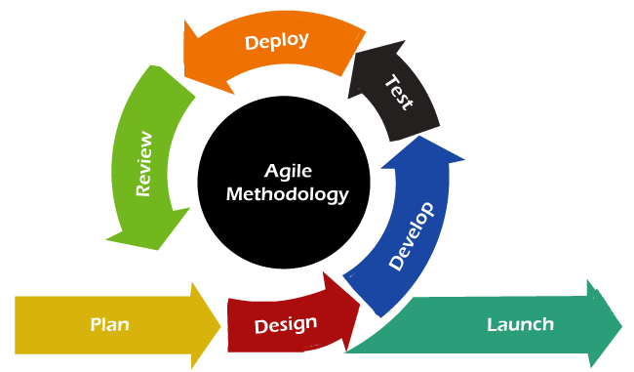

This is a software development approach that emphasises iterative and incremental development, collaboration, and flexibility. Its principles and practices can be adapted and applied to various research projects, including those involving data science and predictive modelling. The Agile technique is frequently employed in projects where needs are anticipated to change over time and where stakeholders' input is critical throughout the research phase.(Rocha et al., 2023). It is a paradigm for software development that starts with planning and moves through deployment with a focus on cutting costs and incorporating changes without jeopardising the process or requiring too much rework. (Al-Saqqa et al., 2020).

**3.1.2 Why Agile Methodology**

The Agile methodology was selected for this project due to its adaptability and iterative nature, which ensures efficient development and stakeholder collaboration.

**Incremental Development:** The project is broken down into sprints, each dedicated to building specific system features and functionalities.

**Stakeholder Involvement:** Regular feedback sessions with IRC-SL representatives help ensure that the system aligns with their operational needs.

**Flexibility:** Agile allows for modifications in project requirements, which is essential given the evolving nature of IRC-SL’s activities.

**3.1.3 Advantages of Agile Methodology**

Encourages active participation from stakeholders, ensuring the system meets user expectations.

Enables the progressive release of functional software, allowing for early testing and validation.

Adapts to changing requirements, making it suitable for dynamic organisational environments.

**3.1.4 Challenges of Agile Methodology**

Requires continuous engagement from stakeholders to provide timely feedback and approvals.

Demands a dedicated and highly committed development team to ensure consistent progress.

**3.1.5 Phases of the Agile Model**

**1. Planning Phase**

The planning phase involves defining the project scope, objectives, and key stakeholders. For this project, the planning process focused on identifying challenges faced by IRC-SL in managing memberships and community engagements. A structured project timeline was developed, outlining key milestones. Additionally, resource allocation, budgeting, and team roles were clearly established.

**2. Requirement Analysis Phase**

During this phase, an extensive requirement-gathering process was conducted to ensure the system effectively meets the needs of IRC-SL. Interviews, questionnaires, and document analysis were utilised to define functional and non-functional requirements. Continuous engagement with stakeholders helped validate these requirements and align them with the organisation's objectives.

**3. System Design Phase**

The system design phase focused on structuring the IRMP to be user-friendly, scalable, and secure. Key design aspects included:

**User Interface (UI) Design:** Developed to be intuitive, ensuring ease of navigation for both administrators and members.

**Database Design:** Structured to securely store and manage membership records, event details, and administrative data.

**System Architecture:** Designed with scalability in mind, allowing future expansions and integrations.

Wireframes and prototypes were created to provide stakeholders with a visual representation of the system before development commenced.

**4. Development Phase**

The development phase involved coding and implementing the system in multiple iterations (sprints) following the Agile methodology. Each sprint focused on delivering specific functionalities such as user registration, event management, and communication tools. Programming languages and frameworks used included Spring Boot for backend development, Next.js, JavaScript, HTML/CSS for frontend, and MySQL for database management.

**5. Testing Phase**

The system underwent rigorous testing to ensure functionality, usability, and security. Agile supports continuous testing throughout development, allowing early identification and resolution of issues. Testing activities included:

**Unit Testing:** Examined individual system components.

**Integration Testing:** Verified seamless interaction between system modules.

**User Acceptance Testing (UAT):** Conducted with IRC-SL stakeholders to validate system usability and effectiveness.

**6. Review & Maintenance Phase**

As IRC-SL’s needs evolve, ongoing maintenance will be necessary to enhance system features and address any emerging issues. Feedback from end-users will guide future updates and refinements.

**3.2 REQUIREMENT GATHERING METHODS**

Requirement gathering is a fundamental process in software development, ensuring that the system aligns with user needs and expectations. Poorly defined requirements can lead to project failures (Kavitha & Thomas, 2011). For the IRMP project, an accurate and comprehensive approach was adopted to meet IRC-SL’s operational needs.

**3.2.1 Importance of Requirement Gathering**

Understanding and managing requirements effectively is crucial for software success. Agile development facilitates continuous requirement refinement through collaboration between developers and stakeholders. Proper requirement gathering ensures the system remains adaptable, prioritising essential functionalities for end-users (Rocha et al., 2023).

**3.2.2 Methods Used for Requirement Gathering**

The following methods were employed to ensure the accuracy and relevance of the IRMP requirements:

**Stakeholder Interviews:** Engaged religious leaders, administrative staff, and community members to gather insights on challenges faced with membership management and communication.

**Questionnaires:** Distributed to IRC-SL members to collect feedback on system requirements and usability expectations.

**Document Analysis:** Reviewed IRC-SL’s reports, membership records, and administrative documents to identify gaps in the current manual system.

**Observation:** Directly observed IRC-SL’s administrative workflows to understand real-time operational challenges and inefficiencies.

The Agile approach emphasises ongoing requirement refinement, ensuring that system development remains aligned with evolving organisational needs. Regular feedback loops and prioritization meetings were conducted throughout the project (Kavitha & Thomas, 2011).

**3.2.3 Limitations of the Methodology**

While Agile offers flexibility and stakeholder collaboration, certain challenges were encountered in the development of the IRMP for IRC-SL (Gheorghe et al., 2020).

1. **Stakeholder Availability:** Limited availability of IRC-SL representatives sometimes delayed feedback cycles.
2. **Scope Creep:** Frequent changes and new requirements introduced during sprints led to timeline adjustments.
3. **Testing Complexity:** Continuous testing required significant development resources.
4. **Documentation Challenges:** Agile prioritises working software over detailed documentation, making it difficult to revisit earlier project components.
5. **Time Management:** The iterative nature of Agile made it challenging to estimate task completion times accurately, leading to occasional scheduling conflicts.

**3.3 SYSTEM ARCHITECTURE**

The system architecture of the Integrated Religious Management Portal (IRMP) is designed to ensure scalability, security, and efficient performance. It follows a multi-tiered architecture that separates the application into different layers, allowing for modularity and flexibility in future enhancements.

**3.3.1 Architectural Overview**

The IRMP is built using a client-server model, incorporating both front-end and back-end components to facilitate seamless interaction between users and the system. The architecture consists of the following key layers:

1. **Presentation Layer (Front-End):**

* This layer provides the user interface for administrators, religious leaders, and members to interact with the system.
* It is developed using **Next.js, JavaScript, HTML, and CSS**, ensuring a responsive and user-friendly experience.
* Users can perform actions such as registration, login, event tracking, and communication through this interface.

1. **Application Layer (Back-End):**

* The back-end processes all business logic and application functionalities.
* It is built using **Spring Boot** for handling requests, authentication, and data processing.
* This layer implements APIs that facilitate communication between the front-end and database.

1. **Database Layer:**

* The database layer is responsible for securely storing and managing member data, event details, and administrative records.
* It is developed using **MySQL**, which ensures structured data storage, efficient retrieval, and role-based access control.
* Security measures such as encryption and authentication mechanisms are applied to protect sensitive information.

**3.3.2 System Components**

The system comprises the following essential components:

**User Management Module:** Handles member registration, authentication, and role-based access control.

**Event Management Module:** Allows administrators to create, update, and manage events while enabling members to register and track participation.

**Communication Module:** Facilitates announcements, notifications, and internal messaging between administrators and members.

**Database Management System:** Ensures secure storage of user and event data, supporting retrieval and modification based on user privileges.

**Security Framework:** Implements authentication, encryption, and access control policies to safeguard system integrity.

**3.3.3 System Deployment**

The IRMP is deployed on a **cloud-based or on-premise server** to ensure accessibility and scalability. It supports web-based access, enabling users to interact with the system from any location with an internet connection. Load balancing and redundancy mechanisms are integrated to enhance system reliability and performance.

The architectural design of the IRMP ensures a robust, scalable, and secure platform that meets the needs of the Inter-Religious Council of Sierra Leone. The structured approach to system layering and module integration allows for efficient management of members, events, and communication processes, supporting the council's long-term growth and operational efficiency.

**3.3.4 Overall System Design**

The **Integrated Religious Management Portal (IRMP)** is designed with a modular architecture to enhance membership management, administrative processes, and communication within the **Inter-Religious Council of Sierra Leone (IRC-SL)**. The system consists of a **user-friendly interface**, a **secure relational database (MySQL)**, and **various functional modules**. The user interface ensures intuitive navigation, role-based access, and responsive design for accessibility across devices. The database structure securely manages user data, events, memberships, and notifications while incorporating encryption and role-based access controls for security. The system is divided into key modules, including **User Management, Event Management, Membership Management, Communication, and Security**, each contributing to efficient system functionality. The **modular design** enables flexibility for future enhancements, ensuring scalability and adaptability to the evolving needs of the IRC-SL while improving operational efficiency and member engagement.

**3.4 ALGORITHM DESIGN**

The **Integrated Religious Management Portal (IRMP)** incorporates a structured algorithmic approach to efficiently handle core functionalities such as **member registration, authentication, event management, and data security**. The system's algorithms are designed to optimise performance, enhance security, and ensure seamless interactions between users and the platform.

1. **Member Registration Algorithm**

* Input: User details (name, email, phone, religious affiliation, etc.).
* Process: Validate input fields → Check for duplicate entries in the database → Hash sensitive data → Store user details in MySQL database.
* Output: Confirmation of successful registration or an error message if validation fails.

1. **Authentication Algorithm (JWT-based Login System)**

* Input: Email and password.
* Process: Validate user credentials → Retrieve hashed password from the database → Compare with input password using bcrypt → Generate JWT token upon successful authentication → Return token to the user.
* Output: Access token or error message if authentication fails.

1. **Event Management Algorithm**

* Input: Event details (title, date, description, location).
* Process: Validate input → Store event in the database → Notify members via email or in-app notifications.
* Output: Event successfully created and accessible to members.

1. **Role-Based Access Control Algorithm**

* Input: User role (Admin, Religious Leader, Member).
* Process: Check user role from the database → Grant or restrict access based on predefined permissions.
* Output: Authorised users can access allowed functionalities, while unauthorised access attempts are denied.

1. **Data Encryption Algorithm for Secure Storage**

* Input: Sensitive user data (passwords, personal details).
* Process: Use AES-256 encryption to secure data before storage → Store encrypted data in the database.
* Output: Securely stored encrypted data, ensuring confidentiality and integrity.

Each algorithm is designed to **enhance efficiency, security, and usability**, ensuring that IRMP meets the operational requirements of IRC-SL while remaining scalable for future enhancements.

**3.5 USER INTERFACE DESIGN**

The user interface (UI) of this application is designed to be intuitive, user-friendly, and accessible to all users, including administrators, religious leaders, and members of the Inter-Religious Council of Sierra Leone (IRC-SL). The UI design follows best practices in usability, ensuring seamless navigation, efficient task execution, and a visually appealing experience.

The system’s interface consists of multiple modules tailored to different user roles. Administrators have access to a dashboard for managing member registrations, events, and communications, while members can easily update their profiles, view announcements, and register for events. The design prioritises clarity and simplicity, using well-structured menus, readable typography, and a responsive layout adaptable to various devices, including desktops, tablets, and mobile phones.

Key UI elements include login and registration pages with authentication features, a dynamic dashboard displaying system updates, event pages with interactive features, and a secure profile management section. The use of colour schemes, icons, and tooltips enhances user experience, making the system easy to navigate even for non-technical users. Accessibility considerations are also incorporated to ensure inclusivity, allowing users with disabilities to interact effectively with the system.

By maintaining consistency in design, minimising complexity, and integrating interactive feedback mechanisms, the IRMP UI enhances user engagement and overall system usability, aligning with the IRC-SL’s goal of improving administrative efficiency and community participation.

**3.6 DATABASE AND DATA MANAGEMENT DESIGN**

The database design for the Integrated Religious Management Portal (IRMP) is structured to ensure efficient data storage, retrieval, and management while maintaining security and integrity. The system follows a relational database model, using MySQL as the primary database management system (DBMS) to handle structured data efficiently. The database is designed to support the core functionalities of the system, including user registration, event management, role-based access control, and secure data handling.

**3.6.1 Database Structure**

The IRMP database consists of multiple tables, each representing a key entity in the system. These include:

* **Users Table:** Stores user information such as name, email, contact details, and roles (e.g., administrator, member, religious leader).
* **Events Table:** Manages event details, including event name, date, location, and participant records.
* **Membership Table:** Handles member registration data, tracking affiliations with religious organisations.
* **Authentication Table:** Stores hashed passwords and login credentials for secure authentication.
* **Announcements Table:** Contains notifications and updates shared with system users.

**3.6.2 Data Management and Security**

To ensure data security and privacy, the database implements:

* **Role-Based Access Control (RBAC):** Restricting access based on user roles to prevent unauthorised actions.
* **Data Encryption:** Protecting sensitive data such as passwords and personal information using encryption techniques.
* **Backup and Recovery Mechanisms:** Implementing regular database backups to prevent data loss in case of system failures.
* **Data Validation:** Enforcing constraints to ensure data accuracy and integrity, such as unique email addresses and required fields.

By designing a well-structured and secure database, the IRMP ensures the reliability, efficiency, and scalability needed to support the Inter-Religious Council of Sierra Leone (IRC-SL) in its operations and community engagement initiatives.

**3.7 SOFTWARE ENGINEERING PRACTICES**

The development of the Integrated Religious Management Portal (IRMP) adheres to industry-standard software engineering practices to ensure efficiency, maintainability, and scalability. These practices guide the entire software development lifecycle (SDLC), from planning to deployment, while promoting code quality, collaboration, and security.

One of the key practices adopted is the **Agile development methodology**, which facilitates iterative development, continuous stakeholder feedback, and incremental feature releases. This approach ensures flexibility in handling evolving requirements and enhances collaboration between developers and IRC-SL stakeholders. Agile promotes adaptability, enabling the development team to refine and improve the system based on real-time feedback.

To manage code changes efficiently, **version control** is implemented using Git. A repository on platforms like GitHub or GitLab is maintained to track modifications, facilitate team collaboration, and ensure code integrity. This helps in maintaining a structured development process, preventing conflicts, and enabling developers to work simultaneously on different features without disrupting the main codebase.

Ensuring **code quality and maintainability** is a priority throughout the development process. The project follows modular programming principles, making it easier to update and extend functionalities in the future. Regular peer code reviews help in identifying and addressing potential issues early, while standardised coding conventions enhance readability and consistency across the codebase.

Security is also a major focus, with several **security best practices** implemented to safeguard sensitive data and protect system integrity. **Role-Based Access Control (RBAC)** is used to restrict access based on user roles, ensuring that only authorised personnel can perform specific actions. Sensitive user information, such as passwords, is encrypted using industry-standard hashing algorithms, while multi-factor authentication (MFA) is considered for additional security. Regular security audits are conducted to identify vulnerabilities and mitigate risks proactively.

To ensure the system functions as expected, **testing and quality assurance** practices are followed rigorously. Unit testing is performed on individual components, while integration testing verifies seamless interactions between different system modules. User acceptance testing (UAT) is conducted with IRC-SL stakeholders to confirm that the system meets their requirements. Where applicable, automated testing tools are employed to detect issues early and improve overall efficiency.

Finally, **Continuous Integration and Deployment (CI/CD)** pipelines are utilised to automate testing and deployment processes. This approach enables faster release cycles, improves software quality, and allows quick rollback in case of any issues. By automating these tasks, the development team can ensure consistent delivery of updates without manual intervention.

By incorporating these best practices, the IRMP is developed to be reliable, scalable, and secure, ensuring a high-quality system that effectively meets the operational needs of the Inter-Religious Council of Sierra Leone (IRC-SL).

**3.8 SCALABILITY AND PERFORMANCE OPTIMISATION**

Scalability and performance optimisation are crucial aspects of the Integrated Religious Management Portal (IRMP) to ensure it can efficiently handle an increasing number of users, data, and operations without compromising performance. The system is designed with scalability in mind, utilising a multi-tier architecture that separates concerns across different layers, including the presentation, business logic, and database layers. This approach enables the system to scale horizontally and vertically as needed.

To optimise performance, efficient database indexing and query optimisation techniques are implemented to reduce retrieval times and enhance response speed. Caching mechanisms are also integrated to minimise redundant database queries and improve system responsiveness. Load balancing techniques, such as distributing user requests across multiple servers, are considered to ensure consistent performance even under high traffic conditions.

Furthermore, asynchronous processing and background jobs are utilised to manage time-consuming operations, such as sending notifications or generating reports, without affecting the system’s responsiveness. Code optimisation, resource-efficient algorithms, and proper memory management practices are also employed to enhance execution speed and reduce system overhead. By implementing these strategies, the IRMP ensures a smooth user experience while maintaining reliability and efficiency as the organisation grows.

**3.9 SYSTEM DESIGN**

The system design phase focuses on developing a detailed physical model that aligns with all documented requirements. This stage encompasses the design of the system architecture, database structure, and user interface to ensure seamless operation and efficient development. The user interface is crafted to provide an intuitive experience for both administrators and members of the Inter-Religious Council of Sierra Leone (IRC-SL). The application architecture is structured to enhance scalability, maintainability, and optimal performance. A comprehensive system design specification is produced and presented to IRC-SL management and stakeholders for review and approval. This phase guarantees that the IRMP supports the IRC-SL’s objectives of improving operational efficiency and fostering interfaith collaboration.

**3.9.1 Proposed System Architecture Design**

The architecture of the IRMP adopts a multi-tier approach, dividing the system into distinct layers for presentation, business logic, and data access. This structured design enhances scalability, maintainability, and security. The key components of the architecture include:

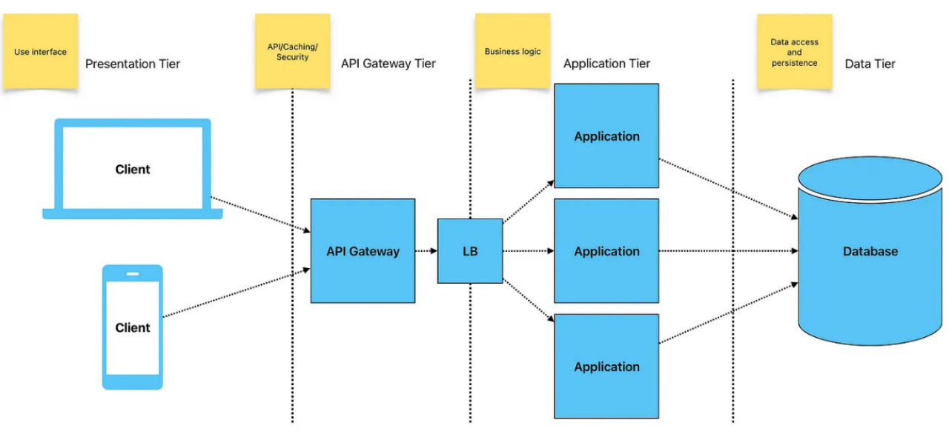

1. Presentation Tier (User Interface): Handles the user interface and interaction, providing users (administrators and members) with access to the system via a web-based application. This layer is designed for user-friendliness and accessibility across multiple devices.
2. API Gateway Tier: The API Gateway enables secure communication between clients and the backend, handling requests, routing them, and storing frequently accessed data for caching.
3. Application Tier (Business Logic Layer): Manages the application’s core functionalities, such as user registration, event management, membership management, announcements, and prayer requests. This layer contains the rules and processes that control the IRMP’s behaviour.
4. Data Access Layer: Interacts with the database to store, retrieve, and update data. This layer ensures data integrity and security while enabling efficient communication between the business logic and the data.

**3.9.2 Advantages of this Architecture**

1. Scalability: Adding more application servers can handle increased user traffic.
2. Performance: The load balancer distributes the workload evenly across servers, reducing response times.
3. Maintainability: Each layer is independent, making it easier to update or replace components without affecting the entire system.
4. Security: Sensitive data is protected through secure communication protocols and role-based access at the API Gateway.
5. Flexibility: Supports various clients (e.g., mobile, web) interacting with the system simultaneously.

**3.9.3 Use case diagram**

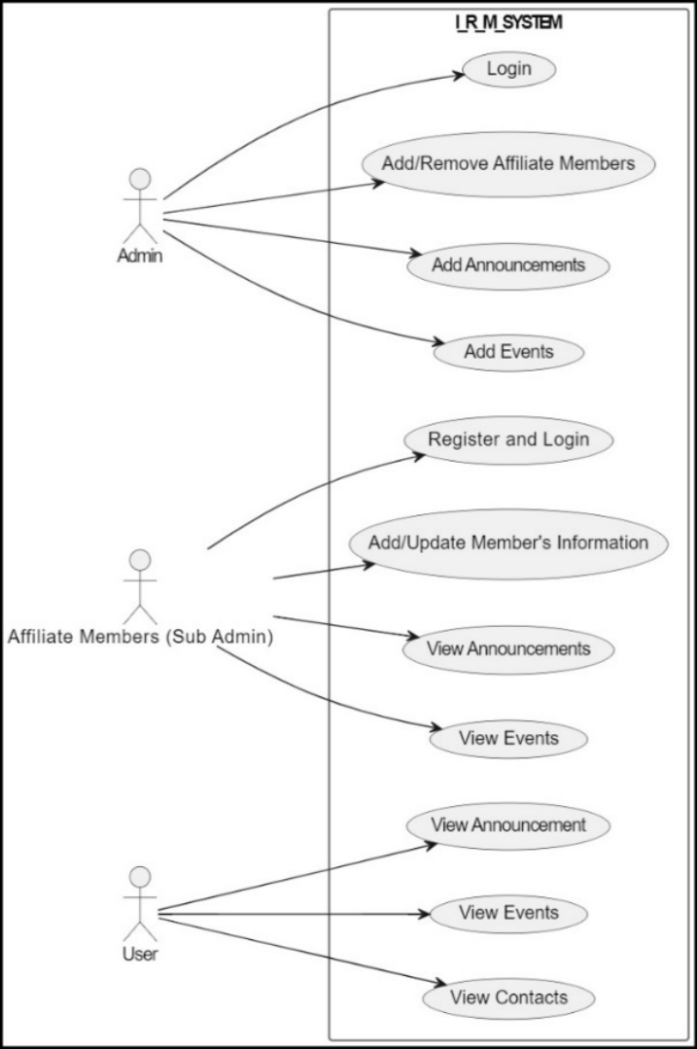This diagram helps visualise the different roles and the actions each role can perform, providing a clear understanding of the system's functionality and user interactions.

**3.9.4 The Entity-Relationship Model**

The Entity-Relationship (ER) Diagram is a visual representation of the relationships between different entities within the system. It illustrates how data is structured and interconnected. An entity refers to a distinct object or concept that holds relevant data. The ER diagram consists of three primary components:

|  |  |  |
| --- | --- | --- |
| **Symbol** | **Name** | **Description** |
|  | Entity | An entity can be any object, place, person or anything. |
| /Users/samueldominickamara/Library/Containers/com.kingsoft.wpsoffice.mac.global/Data/tmp/wps-samueldominickamara/ksohtml/wps2.png | Attribute | An Attribute Describes a property or Characteristics of an entity. |
| /Users/samueldominickamara/Library/Containers/com.kingsoft.wpsoffice.mac.global/Data/tmp/wps-samueldominickamara/ksohtml/wps3.png | Relationship | A Relationship Describes relation between  Entities. |
| /Users/samueldominickamara/Library/Containers/com.kingsoft.wpsoffice.mac.global/Data/tmp/wps-samueldominickamara/ksohtml/wps4.png/Users/samueldominickamara/Library/Containers/com.kingsoft.wpsoffice.mac.global/Data/tmp/wps-samueldominickamara/ksohtml/wps5.png |  | One to One |
| /Users/samueldominickamara/Library/Containers/com.kingsoft.wpsoffice.mac.global/Data/tmp/wps-samueldominickamara/ksohtml/wps6.png/Users/samueldominickamara/Library/Containers/com.kingsoft.wpsoffice.mac.global/Data/tmp/wps-samueldominickamara/ksohtml/wps8.png/Users/samueldominickamara/Library/Containers/com.kingsoft.wpsoffice.mac.global/Data/tmp/wps-samueldominickamara/ksohtml/wps7.png/Users/samueldominickamara/Library/Containers/com.kingsoft.wpsoffice.mac.global/Data/tmp/wps-samueldominickamara/ksohtml/wps9.png |  | Zero or More |
| /Users/samueldominickamara/Library/Containers/com.kingsoft.wpsoffice.mac.global/Data/tmp/wps-samueldominickamara/ksohtml/wps10.png/Users/samueldominickamara/Library/Containers/com.kingsoft.wpsoffice.mac.global/Data/tmp/wps-samueldominickamara/ksohtml/wps11.png/Users/samueldominickamara/Library/Containers/com.kingsoft.wpsoffice.mac.global/Data/tmp/wps-samueldominickamara/ksohtml/wps12.png |  | Many |

**3.9.5 ER Diagram**

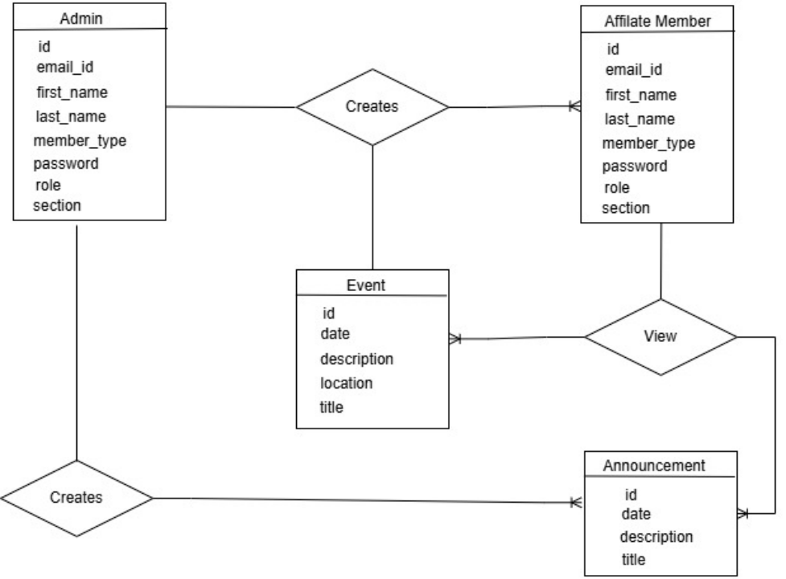

The entity-relationship (ER) model visually represents the system's data structure and relationships. The key entities include:

1. Admin User: Stores user information such as id, email_id, first_name, last_name, member_type, password, role, section.

2. Affiliate Member: Stores user information such as id, email_id, first_name, last_name, member_type, password, role, section.

3. Event: Contains details about church or organisation events, including id, date, description, location, title.

4. Announcement: Represents announcements made by administrators, including id, date, description, title.

**3.9.6 Database Tables**

The data in the system has to be stored and retrieved from the database. Designing the database is part of system design. Data elements and data structures to be stored have been identified at the analysis stage. They are structured and put together to design the data storage and retrieval system.

A database is a collection of interrelated data stored with minimum redundancy to serve many users quickly and efficiently. The general objective is to make database access easy, quick, inexpensive and flexible for the user. Relationships are established between the data items, and unnecessary data items are removed. Normalisation is done to get an internal consistency of data and to have minimum redundancy and maximum stability. This ensures minimising data storage required, minimising chances of data inconsistencies and optimising for updates. The MySQL Access database has been chosen for developing the relevant databases.

**1. User Table**

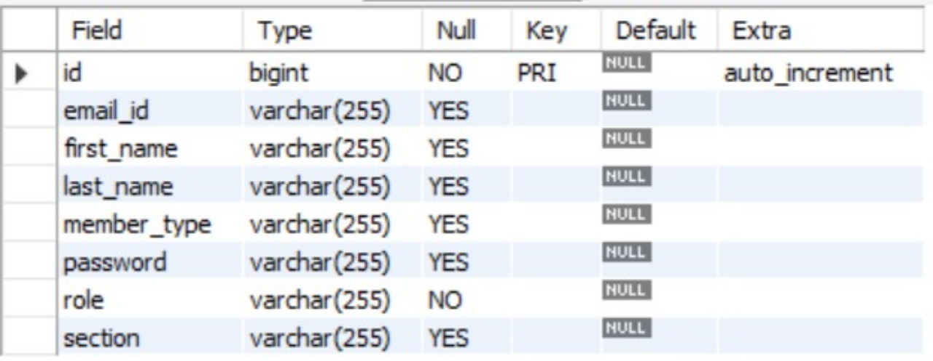

2. Event Table

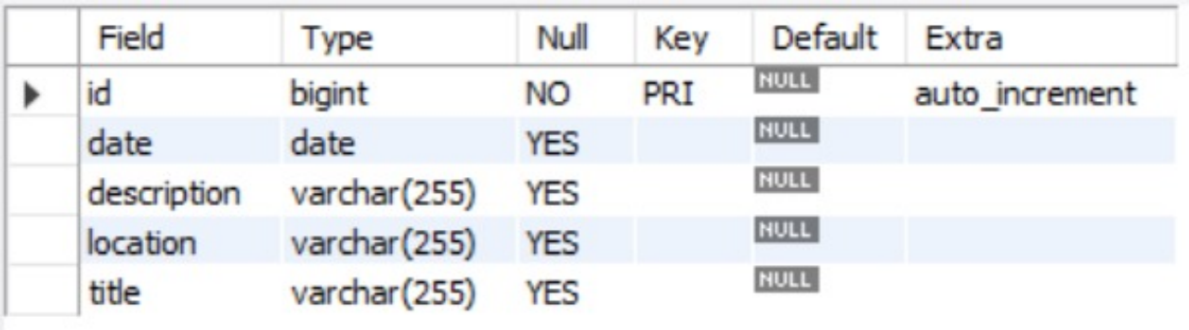

3. Announcement Table

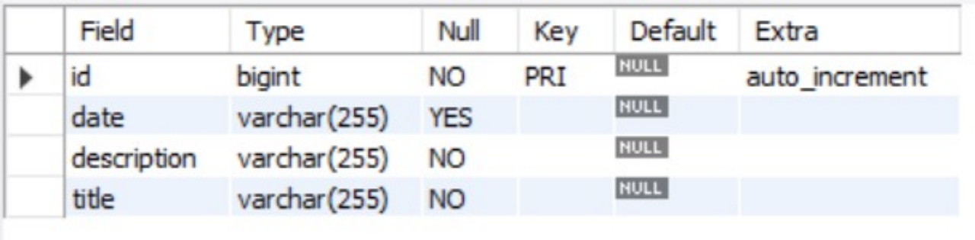

**3.9.7 Normalisation**

Normalisation is applied to the database to minimise redundancy and ensure data integrity. It involves decomposing tables into smaller, well-structured tables.

**3.9.7.1 Stages of Normalisation**

1. First Normal Form (1NF): Removes duplicate columns from tables, ensuring each column holds atomic values and each row is uniquely identified.

2. Second Normal Form (2NF): Ensures all non-key attributes are fully functional and dependent on the primary key.

3. Third Normal Form (3NF): Removes transitive dependencies so that non-key attributes are independent of each other and depend solely on the primary key.

By normalizing the database to at least the 3NF, the IRMP ensures efficient storage, quick retrieval, and minimised data redundancy.

**3.9.8 User Interface Design**

The user interface (UI) design focuses on creating a simple, user-friendly, and responsive interface for all users. The IRMP UI includes:

1. Admin Dashboard: Provides administrators with access to manage members, events, announcements, and prayer requests.

2. Affiliate Member Dashboard: Allows members to view announcements, and events, and update personal information.

3. Responsive Design: The UI adapts to various devices, including desktops, tablets, and mobile phones, ensuring accessibility regardless of user location or device.

4. UI Elements: Consistent UI elements such as buttons, forms, and navigation menus are used to maintain a cohesive look and feel across the application.

**3.10 SECURITY DESIGN**

The security design ensures that the IRMP remains protected against unauthorised access and data breaches. The following security measures are implemented:

1. Authentication and Authorisation: User roles (admin and member) determine access levels within the system, ensuring that only authorised personnel perform specific actions.
2. Encryption: User passwords are hashed and stored securely, and HTTPS protocols are used to protect data during transmission.
3. Input Validation: To prevent malicious attacks such as SQL injection and cross-site scripting (XSS), input fields are validated, and prepared statements are used for database interactions.
4. Regular Security Audits: The system will undergo periodic security assessments to identify vulnerabilities and implement necessary fixes or updates.

**3.10.1 Activity Diagrams**

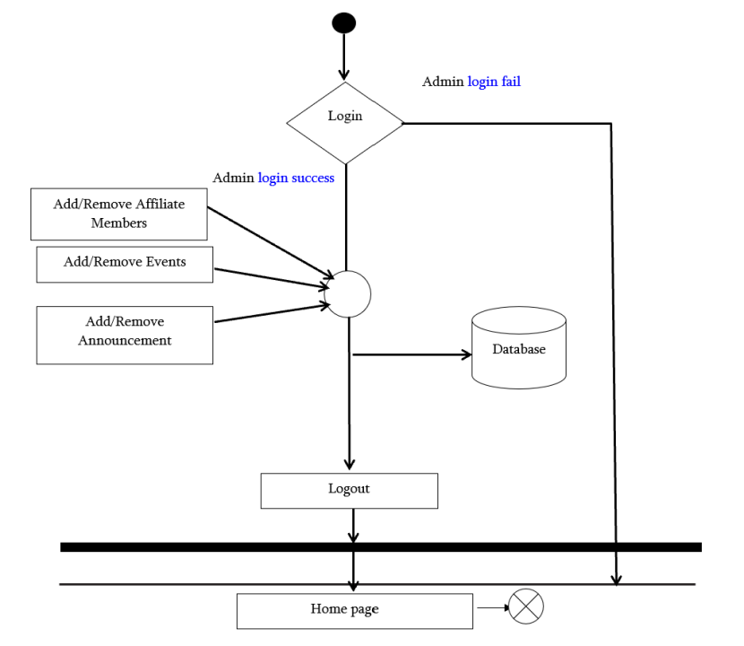**3.10.1.1 Admin Activities Diagram**

**3.10.1.2 Affiliate Member (Sub-Admin) Activities Diagram**

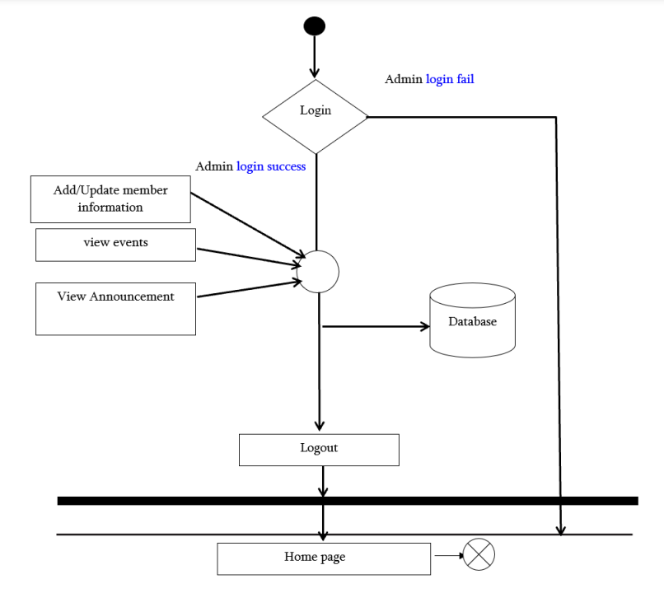

**3.11 DATA COLLECTION METHODS**

The data collection process for the Integrated Religious Management Portal (IRMP) project is essential to ensure that the system meets the needs of the Inter-Religious Council of Sierra Leone (IRC-SL) and its affiliated institutions. A combination of qualitative and quantitative data collection methods was employed to gather comprehensive requirements from key stakeholders, including religious leaders, administrative staff, and members of the council.

One of the primary methods used was **interviews**, where structured and semi-structured questions were posed to key stakeholders to understand their challenges with existing administrative processes. These interviews provided in-depth insights into the specific functionalities and features required for the new system. Additionally, **questionnaires** were distributed to a broader range of IRC-SL members to collect quantitative data regarding user expectations, preferred system features, and usability concerns. The structured nature of the questionnaires ensured consistency in responses and facilitated data analysis.

Other methods included **document analysis**, where existing records, reports, and membership logs were reviewed to identify gaps in the current manual system and determine data management needs. **Observation techniques** were also employed to understand real-time workflows and inefficiencies in the organisation's daily operations. These methods collectively provided a well-rounded understanding of the system requirements, ensuring that the IRMP would be user-friendly, efficient, and aligned with the operational needs of the IRC-SL.

**3.12 DATA ANALYSIS PROCEDURES**

The data analysis procedures for this IRMP project were designed to extract meaningful insights from the collected data, ensuring that the system effectively addresses the needs of the Inter-Religious Council of Sierra Leone (IRC-SL). A combination of qualitative and quantitative analysis techniques was used to interpret stakeholder requirements and system expectations.

For **qualitative data**, thematic analysis was employed to identify recurring patterns and common themes from interviews, observations, and document analysis. Responses from religious leaders, administrative staff, and members were categorised based on their relevance to system functionalities, user experience, and operational improvements. This method allowed for a structured understanding of stakeholder expectations and helped prioritize essential features.

For **quantitative data**, statistical analysis was conducted using responses from questionnaires. Descriptive statistics, such as frequency distributions and percentage analysis, were used to summarise user preferences and expectations regarding system usability, security, and accessibility. The analysed data provided empirical support for decision-making during the system design and development phases. By integrating both qualitative and quantitative findings, the analysis ensured that the IRMP would be tailored to user needs, improving administrative efficiency and religious community engagement.

**3.13 ETHICAL CONSIDERATIONS**

The development and implementation of the Integrated Religious Management Portal (IRMP) adhere to ethical principles to ensure data privacy, security, and fairness in its usage. Ethical considerations are crucial in maintaining the integrity of the system and protecting the rights of all stakeholders involved, including religious leaders, administrators, and members of the Inter-Religious Council of Sierra Leone (IRC-SL).

**1. Data Privacy and Confidentiality**

The IRMP collects and processes sensitive personal information, including member registration details and event records. To uphold privacy, all user data is handled with strict confidentiality, ensuring compliance with global data protection standards such as the **General Data Protection Regulation (GDPR)** and local data privacy laws. Access to personal data is restricted to authorised personnel only, and strong authentication mechanisms, such as role-based access control (RBAC), are implemented to prevent unauthorised access.

**2. Informed Consent**

All users of the IRMP, including administrators and members, must be informed about how their data is collected, stored, and used. During registration, a **user consent agreement** is presented, ensuring individuals are aware of their rights regarding data protection. Users must explicitly agree before providing their personal details.

**3. Security and Integrity**

To prevent data breaches and unauthorised modifications, robust security measures such as **end-to-end encryption, secure authentication protocols, and regular system audits** are enforced. The system logs all transactions to maintain transparency and accountability, ensuring that any attempted security breaches can be traced and mitigated effectively.

**4. Avoiding Bias and Discrimination**

The IRMP is designed to be inclusive and accessible to all religious groups within the IRC-SL. Special attention is given to preventing any form of discrimination or bias in system functionalities. The interface and features are designed to accommodate different religious affiliations, ensuring fairness in data representation and decision-making processes.

**5. Compliance with Ethical Software Development Practices**

The software development process follows ethical coding standards to ensure **fairness, accuracy, and transparency**. Developers adhere to principles such as **open accountability, respect for intellectual property rights, and avoidance of unethical data manipulation**. Additionally, the system undergoes regular ethical reviews to ensure continued compliance.

**6. Responsible Data Retention and Disposal**

To prevent unnecessary data storage, a **data retention policy** is implemented, ensuring that outdated or irrelevant data is securely deleted after a defined period. This prevents excessive data accumulation, reduces security risks, and aligns with best practices in responsible data management.

By incorporating these ethical considerations, the IRMP ensures that the system remains **secure, transparent, and fair**, fostering trust among stakeholders and maintaining the credibility of the Inter-Religious Council of Sierra Leone.

**3.14 LIMITATIONS**

Despite the significant advantages of the Integrated Religious Management Portal (IRMP), several limitations were encountered during its development and implementation. One major challenge was the availability of key stakeholders, as scheduling meetings and gathering feedback often led to delays in refining system requirements. Resource constraints also affected development, limiting the adoption of advanced infrastructure and delaying additional features. While the system is designed for scalability, future growth may require enhanced server infrastructure and database optimisation. Additionally, its dependence on stable internet connectivity poses accessibility challenges for users in remote areas with limited digital infrastructure. Although the interface is user-friendly, some users may require training and continuous support to fully utilise the platform. Security and data privacy concerns remain critical, necessitating ongoing updates to protect against cyber threats. Integration with existing manual or legacy systems also presents complexities that require custom data migration solutions. Despite these limitations, the IRMP remains a valuable tool for improving religious administrative functions and community engagement, with future refinements expected to enhance its functionality, security, and usability.

**CHAPTER FOUR**

**Implementation, Testing, Maintenance and Results.**

**4.1 OVERVIEW**

This chapter focuses on the implementation, testing, and maintenance of the Integrated Religious Management Portal (IRMP) for the Inter-Religious Council of Sierra Leone (IRC-SL). It details the process of transforming the system design into a fully functional application by implementing various components, including the database, backend, and frontend. The chapter also covers the testing strategies employed to ensure system reliability, functionality, and security. Additionally, it discusses the maintenance plan, outlining how the system will be updated and optimised over time to accommodate future requirements and ensure continued efficiency.

**4.2 EXPLORATION AND INSTALLATION**

The exploration and installation phase focuses on setting up the Integrated Religious Management Portal (IRMP) in its intended operational environment. This section details the procedures followed to deploy the system, configure its dependencies, and ensure its smooth operation for the Inter-Religious Council of Sierra Leone (IRC-SL).

**4.2.1 Exploration**

The exploration phase involves assessing the technical and operational requirements of the Integrated Religious Management Portal (IRMP) before deployment. This step ensures that the system is well-suited to the working environment of the Inter-Religious Council of Sierra Leone (IRC-SL) and helps identify any potential challenges that may arise during installation.

**Key activities during this phase included:**

* Hardware and Software Assessment: Evaluating the system's compatibility with the available computing resources, including server specifications, storage capacity, and network infrastructure.
* Network and Security Review: Ensuring that the existing network infrastructure can support secure access and data transfer within the system.
* User Role and Access Control Definition: Identifying different system users, their access levels, and the security measures needed to protect sensitive information.
* Preliminary Performance Testing: Running exploratory tests to estimate system performance under varying conditions to anticipate any bottlenecks before deployment.

This phase was critical in ensuring that the system could be efficiently deployed and integrated into IRC-SL's operational framework without major technical difficulties.

**4.2.2 Installation**

The installation phase involves the structured deployment of the IRMP, ensuring that all necessary software components, databases, and configurations are correctly set up. The installation was carried out following a systematic process to minimise errors and ensure system stability.

**4.2.3 Server Setup and Configuration**

* Installing essential software components, including web servers (Apache/Nginx), database management systems (MySQL), and runtime environments (Java for Spring Boot).
* Configuring firewall settings and enabling SSL encryption for secure communication.

**4.2.4 Database Deployment**

* Creating and structuring the database with relevant tables, relationships, and indexing for optimised performance.
* Populating the database with essential predefined records and securing access with authentication measures.

**4.2.5 Application Deployment**

* Deploying the backend system (Spring Boot) and frontend (Next.js) onto the designated server.
* Configuring API endpoints for smooth interaction between the client interface and database.

**4.2.6 System Testing and Debugging**

* Running installation verification tests to ensure proper functionality.
* Conducting security checks and performance tuning to optimise response times.

**4.2.7 User Access Configuration**

Setting up initial user accounts, assigning roles, and defining permissions based on organisational needs.

Providing IRC-SL stakeholders with credentials and brief training sessions on system usage.

After installation, a post-deployment evaluation was conducted to verify system stability, performance, and security compliance. The successful installation ensured that IRC-SL could seamlessly manage its operations, benefiting from a robust and secure digital platform.

**4.3 FULL SCALE IMPLEMENTATION AND SCALE-UP**

**4.3.1 Full Scale Implementation**

The full-scale implementation of the **Integrated Religious Management Portal** involves deploying the system in its entirety, ensuring that all planned features are fully functional and accessible to the intended users. This phase includes configuring the system for real-world use, integrating it with existing workflows, and addressing any final refinements based on initial testing and feedback. Key aspects of full-scale implementation include:

**System Deployment:** Hosting the application on a secure and scalable server infrastructure.

**User Onboarding:** Training administrators and end-users to effectively utilise the system.

**Data Migration:** Transferring necessary data from previous management methods or legacy systems.

**Performance Monitoring:** Continuously assessing system stability, load handling, and usability.

**Security Measures:** Implementing robust authentication, authorisation, and data protection mechanisms.

**4.3.2 Scale-Up**

Scaling up the **Integrated Religious Management Portal** focuses on expanding its capabilities and reach beyond the initial deployment. This process ensures the system can handle increasing user demand, additional features, and broader organisational needs. The scale-up phase includes:

**Infrastructure Expansion:** Enhancing server capacity, database optimisation, and improving system performance for a larger user base.

**Feature Enhancements:** Adding new functionalities such as AI-driven analytics, multilingual support, or mobile app integration.

**User Base Growth:** Expanding the system to serve a wider audience, including different religious organisations or multiple locations.

**Customisation & Adaptability:** Allowing organisations to tailor the system to their unique requirements while maintaining core functionalities.

**Continuous Improvement:** Gathering user feedback and implementing iterative updates to ensure long-term system sustainability.

By scaling up, the **Integrated Religious Management Portal** can evolve into a comprehensive tool that caters to a diverse range of religious organisations while maintaining efficiency and usability.

**4.4 SYSTEM TESTING AND SPECIFICATION**

The **System Testing and Specification** to ensure the system met its functional, performance, security, and usability requirements. The testing involved various techniques, including unit, integration, end-to-end, load, and security testing, using tools such as **Jest**, **Mocha**, **Spring Boot**, **Selenium**, and **OWASP ZAP**. The tests focused on key functionalities like **Affiliate Member Registration**, **Event Creation**, and **Announcement Management**, ensuring seamless interaction between the frontend (React, Angular) and backend (Node.js, Spring Boot). The results showed that the system performed well under load, handled user data securely, and provided a smooth user experience. All core features passed successfully, confirming that the IRMP meets its specifications and is ready for deployment in a production environment.

**4.4.1 Development and Operating Environment**

This project requires a variety of hardware and platform versions to function correctly and smoothly. The minimal requirement for the needed operating environment is clearly stated in the table below.

### 4.4.2 Software and hardware requirements of the system

|  |  |
| --- | --- |
| **Software Requirements** | |
| Operating Environment | Specification |
| Operation System | Windows 10, 11, Mac OS, Linux |
| Database | MySQL v8.1 |
| Backend Language | Java (Spring Boot) |
| Frontend Languages | Next JS v13.5.3, JavaScript, HTML/CSS, Tailwind CSS |
| Web Browser | Google chrome, Firefox, Opera, Internet explorer |
| Version Control | Git, GitHub |
| API testing | Postman |
| **Hardware Requirements** | |
| Hard drive Space | 128GB or higher |
| RAM | 8GB or higher |
| CPU | Intel Core 2.4 GHz or higher |

**4.4.3 Technologies Used**

The IRMP was developed using a modern web technology to ensure scalability, reliability, and user-friendliness.

**4.4.3.1 Frontend Technologies**

Next.js: It is a powerful React-based framework for building modern web applications with features like server-side rendering (SSR) and static site generation (SSG). Next.js improves the performance and SEO of the system by enabling server-side rendering for dynamic pages like event lists and announcements. Its seamless integration with React ensures a responsive and interactive user interface.

Tailwind CSS: It is a utility-first CSS framework that simplifies styling by offering pre-defined CSS classes for building custom designs directly in HTML. Tailwind CSS allowed for rapid development of the user interface with consistent and responsive designs, eliminating the need for writing extensive custom CSS.

HTML: Is a standard Hyper Text Mark-up Language used to develop web pages. It contains many elements which communicate to the browser on how to display its content.

CSS: Is a Cascading Style Sheets that describes how the elements are shown on a screen. It controls multiple web pages and save time.

JavaScript: Is a scripting language which is used mainly by web browser to develop a dynamic and interactive experience for the user.

**4.4.3.2 Backend Technologies**

Java: It is a versatile, object-oriented programming language that is widely used for building robust, secure, and platform-independent applications. Java is a popular choice for backend development due to its scalability, security, and compatibility.

Spring Boot: Spring Boot is a Java-based framework for creating microservices and enterprise-level applications. It simplifies backend development by providing pre-configured tools and libraries. Spring Boot's modularity and flexibility made it ideal for handling server-side operations, including user authentication, event management, and communication with the database.

Spring Security: A sub-module of the Spring framework used to implement authentication and authorisation in Java applications. Spring Security was used to safeguard sensitive user data, implement secure login mechanisms, and restrict access based on user roles like Admin, Sub-Admin, and Member.

MySQL: It is a relational database management system (RDBMS) widely used for managing structured data in web applications. MySQL was chosen for its performance and reliability in handling structured data like user details, event information, and announcements. It supports complex queries and is compatible with Spring Boot's ORM framework, Hibernate.

**4.4.4 Development Tools**

Visual Studio Code: A lightweight code editor with support for multiple programming languages, extensions, and debugging tools. It was used for the frontend development.

IntelliJ IDEA: IntelliJ IDEA, a Java-specific IDE developed by JetBrains, is known for its advanced features, intuitive interface, and seamless integration with modern tools. It was chosen for building the backend of the IRM System due to its rich feature set.

Git: A distributed version control system that tracks changes in code and facilitates collaboration. Git ensured proper version control during the development process, enabling collaborative coding and easy rollback of changes when necessary.

**4.4.4.1 Testing Tools**

Postman: A platform for testing RESTful APIs by sending requests and analysing responses. Postman was used to validate backend API endpoints developed using Spring Boot, ensuring they returned the expected data to the frontend.

Selenium: An open-source tool for automating web browser interactions to test user interfaces. Selenium automated the testing of the user interface, ensuring that features like event registration, login, and announcement viewing worked as intended.

**4.4.5 Module Implementation Interface**

**4.4.5.1 IRMP Home Page**

The Home Page serves as the main page of the system. It showcases the navigation bar at the top provides quick access to essential pages, such as Login, Admin, Affiliate member. It shows featured events and recent announcements are dynamically displayed to engage users and showcase the system’s capabilities. The home page is accessible to everyone, users do not require to login before accessing the home page. The user only requires the URL (uniform resource locator) to access it. A screenshot of the IRMP home page is shown below.

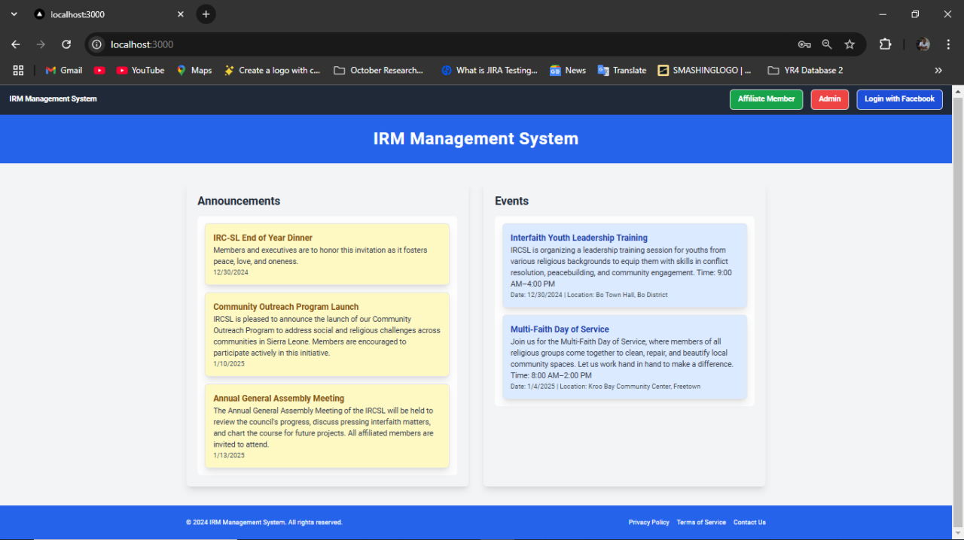

**4.4.5.2 IRMP Login Page**

The Login Page allows users to securely access their accounts within the system. Users need to enter their email and password to login. This page employs secure authentication mechanisms to protect user credentials and prevent unauthorised access. In addition to traditional login fields for email and password, the page features integration with Google and Facebook, allowing users to log in using their existing social media accounts. This functionality simplifies the authentication process, reducing the need for users to remember additional credentials.

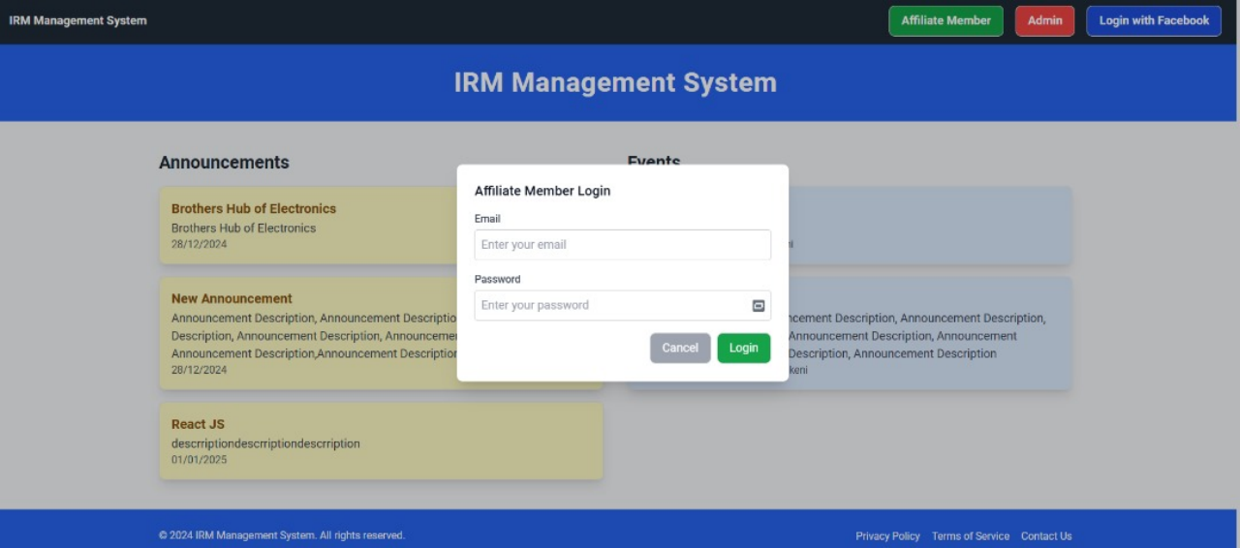

**4.4.5.3 Admin Dashboard**

The Admin Dashboard provides administrators with an overview of the system’s activities. It displays key statistics such as the total number of users, events, and announcements, along with real-time graphs and charts for better data visualisation. Quick links to manage users, events, and announcements. The admin dashboard page allows the administrators to add affiliate members and also delete affiliate members.

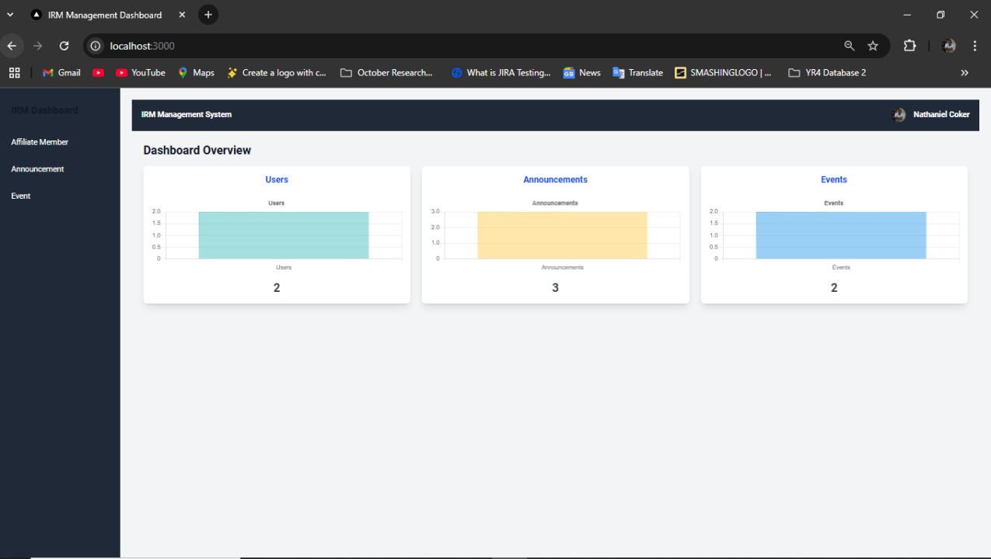

**4.4.5.4 Affiliate Member Dashboard**

The Affiliate Member Dashboard is designed specifically for sub-admins or affiliate members, providing them with the tools and features necessary to assist in managing certain aspects of the system. This dashboard bridges the gap between the full administrative functionality of the admin dashboard and the limited access provided to regular users. Affiliate members can view events and announcements posted by the system administrators. They can also add events and announcements. ensuring they stay informed about the latest updates and developments. Affiliate members can manage view or update their profiles.

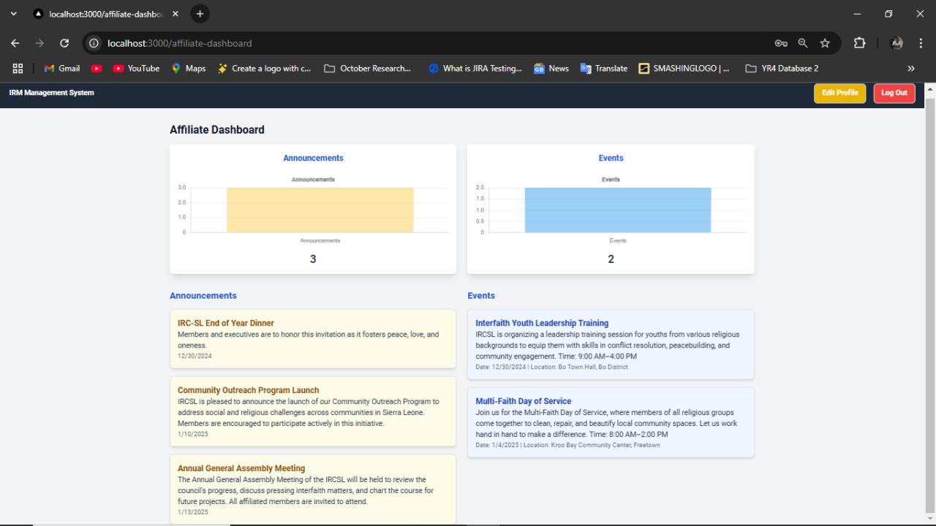

**4.4.5.5 Event Management Page**

The Event Management Page allows administrators and sub-admins to create, update, and delete events. A form is provided for entering event details such as the title, date, location, and description. Existing events are listed in a tabular format with options to edit or delete them. Filters and sorting options enable efficient management of large numbers of events. This page is essential for keeping the system updated with current and future activities.

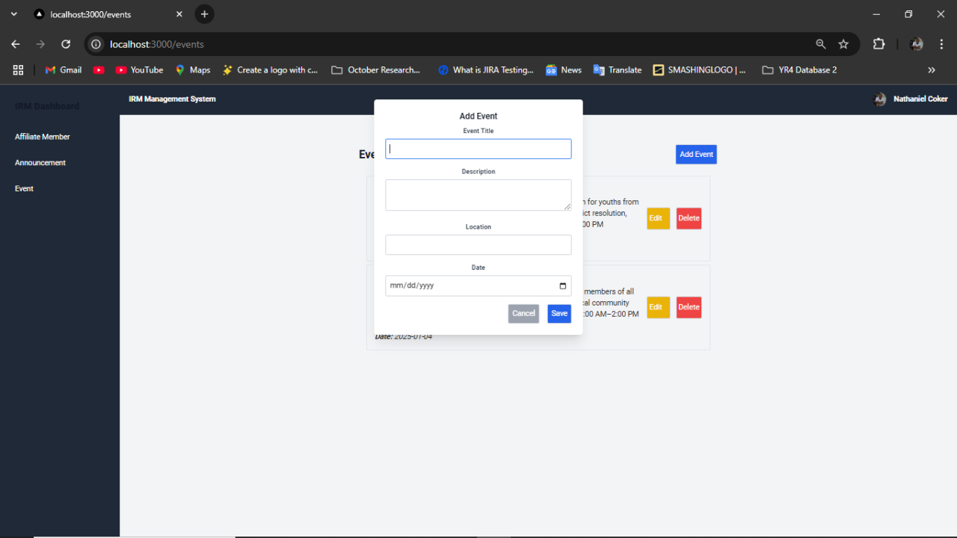

**4.4.5.6 Announcement Management Page**

The Announcement Management Page enables administrators and sub-admins to post, edit, and delete announcements. A form allows for the input of a title, date, and detailed description of the announcement. The page also displays a list of existing announcements with management options. Notifications are sent to users when new announcements are posted, ensuring that important updates reach all members promptly.

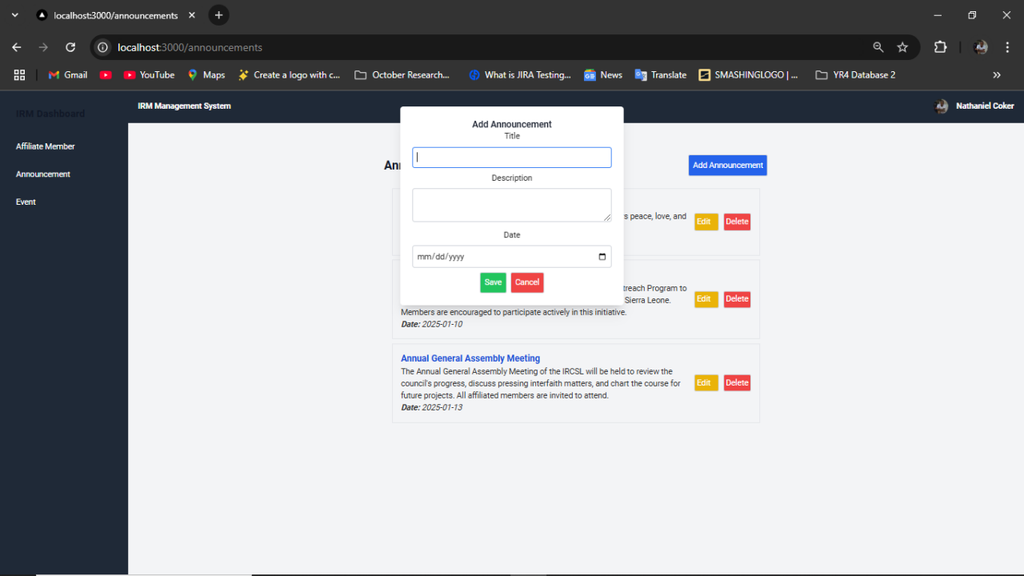

**4.4.5.7 Add Affiliate Member Page**

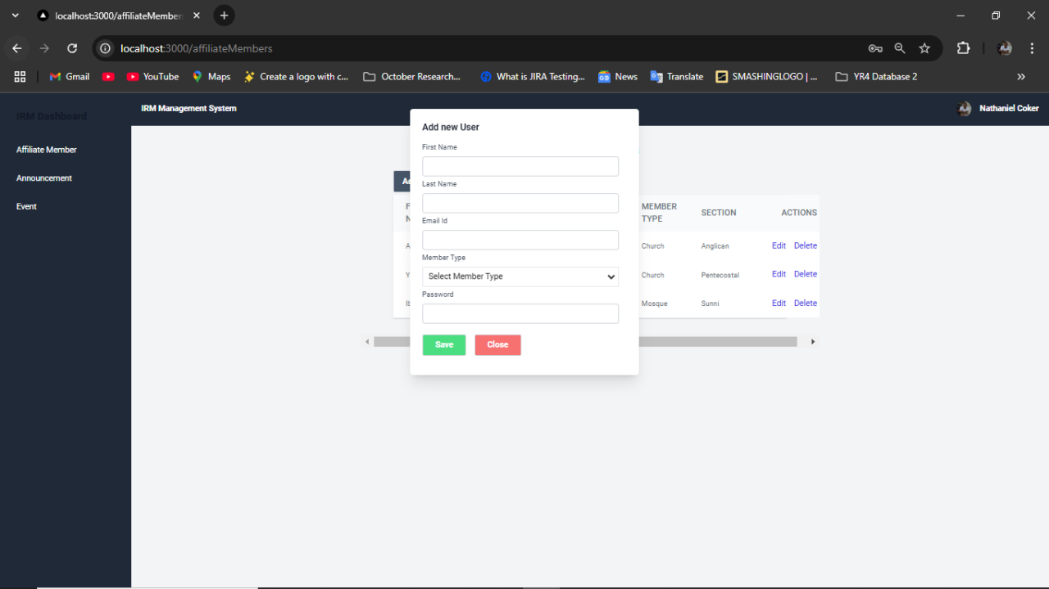The add affiliate member page allows admin to add new members who will serve as sub admin to the system. It displays a form where details such as first name, last name, member type along with the password. Input validation ensures that updates are performed accurately. This page emphasises user creation.

**4.5 SYSTEM PERFORMANCE TEST AND USER TRAINING**

System performance testing for the Integrated Religious Management Portal (IRMP) focused on ensuring the system could handle varying loads, maintain responsiveness, and scale effectively under increasing demands. Load, stress, scalability, and endurance testing were conducted using tools like **Apache JMeter** and **Locust**, simulating different traffic conditions to measure system performance and identify bottlenecks. Additionally, the system's scalability was tested to ensure it could handle growth, and endurance testing ensured long-term stability under continuous use. To complement this, user training was crucial for ensuring efficient use of the system. Comprehensive training materials, including user manuals, video tutorials, and FAQs, were provided, along with interactive sessions tailored to different user roles (administrators and regular users). A helpdesk and community forums were established for ongoing user support. Performance testing confirmed the system's robustness, while thorough user training ensured that both administrators and end-users were equipped with the knowledge to utilise the system effectively, ensuring a smooth deployment and sustained success.

**4.6 SYSTEM SECURITY AND MAINTENANCE**

**4.6.1** **Physical and Virtual Security**

**Physical Security**: The physical security of the Integrated Religious Management Portal (IRMP) is managed through secure cloud infrastructure. The application is hosted on cloud servers with strict access controls, backed by a robust infrastructure. These cloud data centres are safeguarded with advanced security protocols such as 24/7 surveillance, biometric access control, and restricted access to authorised personnel only. Routine audits are conducted to ensure compliance with industry safety and security standards, protecting against unauthorised physical access, natural disasters, and environmental threats. This ensures a solid foundation for secure data storage and processing in the IRMP.

**Virtual Security**: Virtual security measures are critical for safeguarding user data transmitted and stored within the system. Secure login mechanisms, such as email/password authentication, ensure that only authorised users can access the IRMP. Communications between the application and its servers are encrypted using HTTPS, preventing unauthorised interception or tampering of data during transmission. The backend is built using **Spring Boot** and **Node.js**, ensuring secure and efficient server-side operations. The system uses **MySQL** for data storage, ensuring secure access and integrity of user data. Data is encrypted both during transit and at rest, minimising risks related to unauthorised access. Regular security audits, vulnerability assessments, and penetration testing are conducted to identify and mitigate potential threats, ensuring that the system adheres to data protection regulations and remains secure from internal and external vulnerabilities. The frontend is developed using **Angular** and **Tailwind CSS**, focusing on accessibility, responsiveness, and security. Through these measures, the IRMP effectively ensures the integrity and security of user data at all levels of operation.

**4.6.2 Preventive, Corrective, Predictive**

**Preventive** measures in the Integrated Religious Management Portal (IRMP) are designed to mitigate risks before they arise. These measures include secure coding practices, regular security audits, and a scalable infrastructure to accommodate growing demands. The system implements secure user authentication, data encryption, and role-based access control to protect sensitive data and prevent unauthorised access, ensuring the safety of both user information and system operations.

**Corrective** actions are implemented when issues occur. Any bugs or vulnerabilities are addressed promptly through regular updates. Real-time monitoring and comprehensive error logs are utilised to quickly identify, diagnose, and resolve issues, maintaining the integrity and reliability of the system. The corrective approach ensures that the system remains functional and secure despite unexpected challenges or faults.

**Predictive** measures focus on anticipating and preparing for potential challenges. Using analytics and scalable infrastructure, the system can forecast traffic spikes, performance issues, or other potential bottlenecks. This allows the system to dynamically adjust, scaling resources and optimising performance to meet future demands effectively, ensuring consistent service quality and stability over time.

**4.7 TECHNICAL ANALYSIS**

The Integrated Religious Management Portal (IRMP) was developed using modern web technologies, including Node.js and Spring Boot for the backend and React, Angular, and Tailwind CSS for the frontend, ensuring a responsive and scalable application. MySQL was chosen for data storage, providing a reliable and structured database solution for storing critical data, such as user profiles, events, member information, and performance metrics. Firebase Authentication is used for secure logins via email/password and Google sign-in, ensuring only authorised users can access the system. Role-based access control is implemented through MySQL database rules, ensuring secure and appropriate access based on user roles, such as administrators and regular members.

The performance of the IRMP is optimised with asynchronous operations that minimise latency and ensure smooth user experiences. Additionally, the system is designed with automatic scaling and load balancing mechanisms to efficiently handle varying traffic loads and ensure scalability as the user base grows. The application’s user interface is designed with a focus on accessibility, simplicity, and intuitive navigation, enabling both administrators and members to interact with the system seamlessly. These technical decisions combine to create a secure, scalable, and high-performance platform that meets the needs of the IRMP users, providing an optimal experience for both administrative users and members.

**CHAPTER FIVE**

**Conclusion, Lesson Learnt and Recommendation.**

**5.1** **SUMMARY OF KEY FINDINGS OF THE RESULTS**

The development and testing of the Integrated Religious Management Portal (IRMP) revealed several key findings regarding its functionality, security, performance, and user experience.

**System Performance**: The system demonstrated robust performance under varying traffic loads, with successful scalability and load balancing ensuring it could handle increasing numbers of users and data requests without compromising speed or reliability. Stress and load testing confirmed that the system could scale dynamically and adapt to higher usage demands, ensuring consistent performance across multiple user interactions.

**Security**: The system's security measures, including secure login mechanisms, data encryption, and role-based access control, were effective in safeguarding sensitive data. Regular security audits and penetration testing helped identify and mitigate potential vulnerabilities, ensuring compliance with data protection regulations and providing a secure environment for both users and administrators.

**Usability**: The user interface, developed using **Angular** and **Tailwind CSS**, was well-received for its simplicity and accessibility. The design focused on providing an intuitive and seamless navigation experience for both administrators and members, ensuring users could interact with the system efficiently. User feedback highlighted the ease of use, particularly with the mobile-friendly interface.

**Data Integrity**: The **MySQL** database provided reliable data storage, ensuring that information was securely stored and consistently accessible. The system's use of asynchronous operations contributed to minimising latency and ensuring smooth transactions, even when handling complex queries or large amounts of data.

**System Flexibility**: The application’s ability to integrate with different components and accommodate additional features made it adaptable to evolving needs. The use of **Spring Boot** and **Node.js** for backend development ensured that the system was flexible and could be easily expanded with new functionalities in the future.

IRMP met its objectives of providing a secure, scalable, and high-performance platform for managing religious-related events, member information, and communications. The system proved to be reliable, user-friendly, and capable of supporting ongoing growth and future enhancements.

**5.2 DISCUSSION OF FINDINGS**

The development and implementation of the Integrated Religious Management Portal (IRMP) yielded several important findings that highlight both the strengths and areas for potential improvement within the system.

**System Performance and Scalability**: The IRMP demonstrated excellent performance under varied traffic conditions, particularly with its ability to scale efficiently. The system's use of **Node.js** and **Spring Boot** for backend services allowed for asynchronous operations that minimised latency, ensuring that user interactions remained smooth even with large volumes of data. However, while the system performed well under the tested conditions, further testing under extreme traffic spikes would help assess its long-term scalability and performance consistency, especially in real-world environments with a large user base.

**Security Measures**: The security measures implemented in the system, including **MySQL** for data storage, secure login via email/password authentication, and encryption of data both in transit and at rest, effectively safeguarded sensitive user information. Role-based access control ensured that only authorised users could access specific data or perform critical functions. Despite these strong measures, regular security assessments and penetration testing are recommended as part of ongoing maintenance to address emerging threats, especially with the increasing sophistication of cyberattacks. Additionally, future improvements could include multi-factor authentication for an extra layer of security.

**User Experience and Interface**: The use of **Angular** and **Tailwind CSS** for the front-end design resulted in a clean, responsive, and intuitive interface. The design focused on user accessibility, which contributed to positive feedback from users, particularly in terms of ease of navigation. However, some users suggested that further improvements in the mobile interface could enhance the overall user experience, especially in terms of touch responsiveness and layout adjustments for different screen sizes.

**Data Integrity and Management**: The **MySQL** database performed well in handling and managing the application’s data, ensuring consistency and accessibility. Data queries were efficiently executed, and the use of encryption minimised risks related to unauthorised access. However, it is essential to continue optimising database queries, especially as the dataset grows, to avoid potential bottlenecks in performance.

**Flexibility and Future Enhancements**: The use of **Spring Boot** and **Node.js** in the backend made the system highly adaptable to future enhancements, enabling smooth integration of new features. The modular design also allows for easier updates and maintenance. However, as the system evolves, more advanced features, such as event scheduling automation or real-time notifications, could be integrated to enhance the functionality and user engagement.

In conclusion, while the IRMP successfully met its primary objectives of providing a secure, scalable, and user-friendly platform, continuous monitoring and updates will be necessary to ensure it can handle increasing demands and adapt to new technological trends. The system is well-positioned for future growth, with strong foundations in place for security, performance, and flexibility.

**5.3 COMPARISON WITH LITERATURE**

The Integrated Religious Management Portal (IRMP) follows best practices and standards outlined in existing literature on secure, scalable, and user-friendly web applications. In terms of **security**, the system aligns with studies recommending **data encryption**, **secure authentication**, and **role-based access control**, using methods such as email/password authentication and HTTPS encryption. For **performance and scalability**, the use of **Node.js** and **Spring Boot** for asynchronous operations mirrors the recommendations in literature for handling dynamic traffic and ensuring scalability. In **user experience (UX)**, the system's responsive design, developed with **Angular** and **Tailwind CSS**, supports the literature's emphasis on accessibility and intuitive navigation. The choice of **MySQL** for data storage aligns with recommendations for relational databases in transactional applications, ensuring data integrity and efficient management. Finally, the system’s **modular and flexible architecture**, built with scalable backend technologies, is in line with literature on the importance of adaptability in modern software development. Overall, the IRMP successfully implements the key principles from the literature, ensuring security, performance, and user satisfaction.

**5.4 PRACTICAL APPLICATIONS**

The Integrated Religious Management Portal (IRMP) offers practical applications that enhance the management of religious organisations. It supports **event management**, allowing for seamless scheduling, registration, and communication of events. The system also facilitates **member management**, helping track member details and participation while ensuring data security. With features for **communication and announcements**, it enables efficient distribution of updates and notifications. **Financial management** tools allow for tracking donations and providing transparency. Additionally, the IRMP supports **educational programs**, offering tools for course management and student progress tracking. The system is **scalable** and can grow with the organisation, while **mobile accessibility** ensures users can stay connected on-the-go. Overall, the IRMP is a comprehensive platform that streamlines administrative tasks and enhances community engagement in religious organisations.

**5.5 CONCLUSIONS DRAWN FROM THE RESEARCH**

The Integrated Religious Management Portal (IRMP) successfully combines modern web technologies, such as **Node.js**, **Spring Boot**, and **MySQL**, to create a secure, scalable, and user-friendly platform for religious organisations. The system effectively protects user data through **encryption, role-based access control**, and **secure authentication**. Its **user-centric design** with **Angular** and **Tailwind CSS** ensures a positive user experience. The system is scalable and adaptable, capable of growing with organisational needs. It offers practical applications like **event management**, **member tracking**, and **financial management**, which streamline operations. Although the system meets its objectives, there is room for future improvements, particularly in mobile optimisation and multi-factor authentication. Overall, the IRMP provides an efficient solution for managing religious organisations' administrative tasks while remaining flexible for future growth.

**5.6 RECOMMENDATIONS FOR FUTURE RESEARCH**

Future research on the Integrated Religious Management Portal (IRMP) could focus on several areas to enhance its capabilities. These include developing a **mobile app** for better accessibility, integrating with **external systems** like payment gateways and social media, and incorporating **advanced data analytics** for actionable insights. Adding **multi-language** and **multi-currency** support would make the system more adaptable globally. Security could be strengthened with **multi-factor authentication** and **AI-based anomaly detection**, while **AI and machine learning** could automate administrative tasks. Research on **performance optimisation** and **usability studies** would further improve the system’s scalability and user experience. These improvements would help IRMP meet the evolving needs of religious organisations worldwide.

**5.7 LESSONS LEARNED**

The development of the Integrated Religious Management Portal (IRMP) highlighted several key lessons. Clear and comprehensive **requirements gathering** ensured the system met user needs. Focusing on **scalability** allowed the system to handle future growth, while prioritising **security** through encryption, access control, and audits protected sensitive data. The **user experience** was enhanced through intuitive design, emphasising the importance of **UX**. Building a **flexible system** for evolving needs proved essential for long-term sustainability. **Continuous collaboration** with stakeholders and thorough **testing** ensured the system met expectations. Finally, effective **time and resource management** helped maintain progress and meet project goals. These lessons are vital for ensuring the continued success and adaptability of the IRMP.

**5.8 FINAL THOUGHTS**

The development of this system has been an insightful and rewarding journey, combining modern technologies with the unique needs of religious organisations. By leveraging tools such as **Node.js**, **Spring Boot**, **MySQL**, and **Angular**, the system provides a scalable, secure, and user-friendly platform that supports key functions like event management, member tracking, and financial oversight. The project underscored the importance of clear requirements, a focus on **user experience**, and the necessity for robust **security** measures.

As the system continues to evolve, the lessons learned throughout its development will guide future improvements, particularly in areas like **mobile optimisation, integration with external tools**, and **enhanced security features**. IRMP offers a practical solution for religious organisations, streamlining their administrative processes and strengthening community engagement. Moving forward, the system’s adaptability will ensure that it remains relevant and effective in meeting the growing and changing needs of these organisations, providing a solid foundation for their digital transformation in the years to come.

**References**

Ally, M. (2004). Foundations of educational theory for online learning. In T. Anderson (Ed.), *Theory and practice of online learning* (pp. 3–31). Athabasca University Press.

Bevan, N. (2009). *Usability benchmarking: A review of the literature*. International Journal of Human-Computer Studies, 67(8), 568–588. <https://doi.org/10.1016/j.ijhcs.2009.05.003>

Bower, M., Cummings, C., & Stobart, R. (2015). The impact of mobile learning on student achievement and engagement: A systematic review. *Computers & Education*, 87, 39-58. <https://doi.org/10.1016/j.compedu.2015.03.005>

Clark, R. C. (2014). Evidence-based training methods: A guide for training professionals (3rd ed.). AMACOM.

Hattie, J., & Timperley, H. (2007). The power of feedback. *Review of Educational Research*, 77(1), 81–112. <https://doi.org/10.3102/003465430298487>

Liu, D., & Zhang, X. (2020). Privacy and security concerns in mobile learning applications: A review. *Journal of Educational Technology & Society*, 23(3), 91–106.

Nadkarni, A., & Zhao, Y. (2016). Cloud computing for education: A survey of the applications, benefits, and security risks. *Education and Information Technologies*, 21(4), 975–992. <https://doi.org/10.1007/s10639-016-9471-0>

Preece, J., Rogers, Y., & Sharp, H. (2015). *Interaction design: Beyond human-computer interaction* (4th ed.). Wiley.

Wang, X., Zhang, S., & Zhang, Z. (2015). Designing user interfaces for mobile learning applications: A usability study. *Computers in Human Behaviour*, 47, 121–130. <https://doi.org/10.1016/j.chb.2015.01.029>

Zhang, Y., Li, X., & Chen, Q. (2018). Performance optimisation strategies for mobile learning applications. *Educational Technology Research and Development*, 66(5), 1035-1053. <https://doi.org/10.1007/s11423-018-9556-4>

Zhao, M., Yang, W., & Liu, W. (2021). Security features in mobile learning platforms: A review of Firebase’s capabilities. *International Journal of Educational Technology in Higher Education*, 18(1), 36. <https://doi.org/10.1186/s41239-021-00275-9>

Zhou, X., Li, X., & Liu, S. (2019). Data privacy protection in mobile education applications: A study on GDPR compliance. *Journal of Educational Computing Research*, 57(4), 919–935. <https://doi.org/10.1177/0735633119841584>

Ally, M., & Tsinakos, A. (2014). Mobile learning: Structures, agency, practices. Springer.

Firebase. (n.d.). Firebase documentation. Firebase. Retrieved January 27, 2025, from <https://firebase.google.com/docs>

**APPENDIX - A**

**Research Study Activity Gantt Chat**

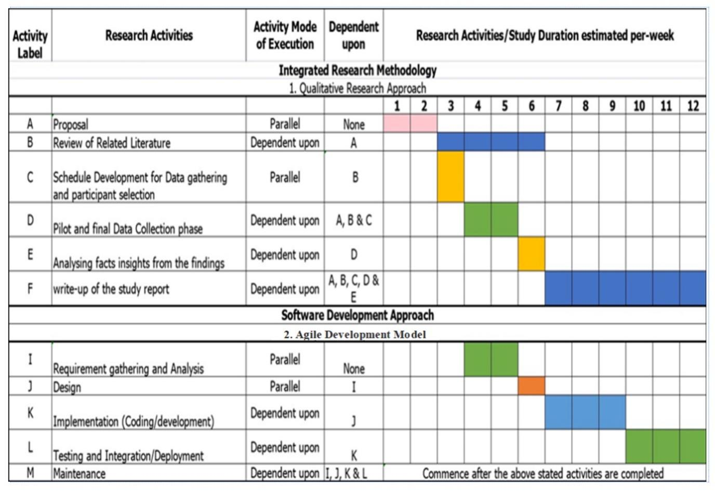

**Figure 15**. Source: D. S. Fornah (January 2017).

**APPENDIX – B**

**AnnouncementList.js code:**

import React, { useState, useEffect } from "react";  
import EditAnnouncement from "./EditAnnouncement";  
  
const AnnouncementList = ({ announcement }) => {  
 const ANNOUNCEMENT_API_BASE_URL = "http://localhost:8080/api/v1/announcements";  
 const [announcements, setAnnouncements] = useState([]);  
 const [loading, setLoading] = useState(true);  
 const [editingId, setEditingId] = useState(null);  
  
 useEffect(() => {  
 const fetchAnnouncements = async () => {  
 setLoading(true);  
 try {  
 const response = await fetch(ANNOUNCEMENT_API_BASE_URL);  
 const data = await response.json();  
 setAnnouncements(data);  
 } catch (error) {  
 console.error("Failed to fetch announcements", error);  
 }  
 setLoading(false);  
 };  
  
 fetchAnnouncements();  
 }, [announcement]);  
  
 const handleEdit = (id) => {  
 setEditingId(id);  
 };  
  
 const handleSave = async (updatedAnnouncement) => {  
 const response = await fetch(`${ANNOUNCEMENT_API_BASE_URL}/${updatedAnnouncement.id}`, {  
 method: "PUT",  
 headers: {  
 "Content-Type": "application/json",  
 },  
 body: JSON.stringify(updatedAnnouncement),  
 });  
  
 if (response.ok) {  
 setAnnouncements((prev) =>  
 prev.map((ann) => (ann.id === updatedAnnouncement.id ? updatedAnnouncement : ann))  
 );  
 setEditingId(null);  
 }  
 };  
  
 const handleDelete = async (id) => {  
 const response = await fetch(`${ANNOUNCEMENT_API_BASE_URL}/${id}`, {  
 method: "DELETE",  
 });  
 if (response.ok) {  
 setAnnouncements((prev) => prev.filter((announcement) => announcement.id !== id));  
 }  
 };  
  
 return (  
 <div className="container mx-auto my-8 max-w-4xl px-4"> {/* Centre and set max width */}  
 {/*<h2 className="text-xl font-bold">Announcements</h2>*/}  
 {loading ? (  
 <p>Loading...</p>  
 ) : (  
 <ul>  
 {announcements.map((announcement) => (  
 <li key={announcement.id} className="border p-4 mb-2 flex items-centre justify-between">  
 {editingId === announcement.id ? (  
 <EditAnnouncement announcement={announcement} onSave={handleSave} />  
 ) : (  
 <>  
 <div>  
 <h3 className="text-lg font-semibold">{announcement.title}</h3>  
 <p>{announcement.description}</p>  
 <i><strong>Date:</strong> {announcement.date}</i>  
 </div>  
 <div className="ml-auto flex space-x-2">  
 <button  
 onClick={() => handleEdit(announcement.id)}  
 className="bg-yellow-500 text-white p-1 rounded pr-4"  
 >  
 Edit  
 </button>  
 <button  
 onClick={() => handleDelete(announcement.id)}  
 className="bg-red-500 text-white p-1 rounded"  
 >  
 Delete  
 </button>  
 </div>  
 </>  
 )}  
 </li>  
 ))}  
 </ul>  
 )}  
 </div>  
 );  
};  
  
export default AnnouncementList;

**AffiliateNavbar.js code:**

import { useRouter } from "next/router";  
import { signOut } from "next-auth/react";  
import { useState, useEffect } from "react";  
import RegistrationForm from "./RegistrationForm";  
  
const AffiliateNavbar = ({ onEditProfileClick, section, onNewSubSection }) => {  
 const router = useRouter();  
 const [showRegistrationForm, setShowRegistrationForm] = useState(false);  
 const [userId, setUserId] = useState(null);  
  
 const handleLogout = async () => {  
 try {  
 // Clear local storage data  
 localStorage.removeItem("email");  
 localStorage.removeItem("token"); // Assuming token exists for session management  
  
 // Log out user using next-auth  
 await signOut({ redirect: false });  
  
 // Redirect to the default homepage  
 router.push("/");  
 } catch (error) {  
 console.error("Error during logout:", error);  
 alert("Failed to log out. Please try again.");  
 }  
 };  
  
 useEffect(() => {  
 const fetchUserId = async () => {  
 const email = localStorage.getItem("email");  
 if (!email) {  
 console.error("Email is not available in localStorage.");  
 return;  
 }  
  
 try {  
 const response = await fetch(  
 `http://localhost:8080/api/v1/users/profile/${email}`  
 );  
 if (response.ok) {  
 const data = await response.json();  
 setUserId(data.id); // Set userId from profile  
 } else {  
 console.error("Failed to fetch user ID.");  
 }  
 } catch (error) {  
 console.error("Error fetching user ID:", error);  
 }  
 };  
  
 fetchUserId();  
 }, []);  
  
 return (  
 <>  
 <div className="bg-gray-800">  
 <div className="h-16 px-5 flex items-centre justify-between">  
 <p  
 className="text-white font-bold cursor-pointer"  
 onClick={() => router.push("/")} // Navigate to homepage/dashboard  
 >  
 IRM Management System  
 </p>  
 <div className="flex items-centre space-x-4">  
 <button  
 onClick={onEditProfileClick}  
 className="bg-yellow-500 text-white px-4 py-2 rounded-lg font-semibold"  
 >  
 Edit Profile  
 </button>  
 <button  
 onClick={() => setShowRegistrationForm(true)}  
 className="bg-green-500 text-white px-4 py-2 rounded-lg font-semibold"  
 >  
 Register Church/Mosque  
 </button>  
 <button  
 onClick={handleLogout}  
 className="bg-red-500 text-white px-4 py-2 rounded-lg font-semibold"  
 >  
 Log Out  
 </button>  
 </div>  
 </div>  
 </div>  
 {showRegistrationForm && userId && (  
 <RegistrationForm  
 section={section} // Pass section from props  
 userId={userId} // Pass fetched userId  
 closeForm={() => setShowRegistrationForm(false)} // Close handler  
 onNewSubSection={onNewSubSection} // Notify parent of new subsection  
 />  
 )}  
 </>  
 );  
};  
  
export default AffiliateNavbar;

# Appendix C

## 1. Questionnaire

Dear Respondents, Greetings!

This research is conducted by ………………………………………………………………..

Thank you very much for your time and participation.

**Instructions**

* 1. Kindly read the instructions carefully before answering.
  2. Choose the correct answer.

**Section 1: Background Information**

This section gathers demographic data to categorize responses.

1. Name (Optional):
2. Age Bracket:
   * 18-25 Yeas
   * 26-35 years
   * 36-45 years
   * 46-50 years
   * Above 50 years
3. Gender:
   * Male
   * Female
4. Role in the Organisation/Community:
   * Religious leader
   * Administrative staff
   * Community member
   * Volunteer
5. Affiliation: (e.g., church, mosque, temple, etc.)
   * Church
   * Mosque
   * Temple
   * Other
6. Years of Involvement in Religious Activities
   * Less than 1 year
   * 1-5 years
   * 6-10 years
   * Above 10 years

**Section 2: Current Practices and Challenges**

Questions to understand how administrative and engagement tasks are currently handled.

1. How does your organisation manage administrative tasks such as event planning, member registration, and financial tracking?
   * Paper-based system
   * Spreadsheets
   * Specialized software
   * Other (Please specify)
2. What challenges do you face with the current method of managing administrative functions?
   * Inefficiency
   * Lack of coordination
   * Difficulty in accessing information
   * Other (Please specify)
3. Are there specific community engagement activities (e.g., sermons, events, charity programs) that could be improved with better management tools?
   * Yes
   * No

If yes, Please specify………………………………………………………………………………………………………………………………………………………………………

1. How often do you use digital tools (e.g., email, social media) for communication and engagement?
   * Always
   * Often
   * Occasionally
   * Never
2. What is your biggest frustration in managing community-related tasks?
   * Poor communication
   * Limited participation
   * Lack of transparency

* Other (Please specify)

**Section 3: Features and Expectations of the System**

1. What features do you think would be most beneficial in a religious management system? (Select all that apply)
   * Event scheduling and notifications
   * Member database management
   * Financial management (donations, expenses, etc.)
   * Communication tools (e.g., newsletters, SMS)
   * Volunteer management
   * Other (Please specify)

1. How important is the integration of a web-based system for your institution?
   * Extremely important
   * Very important
   * Not important
2. Would you prefer the system to support multiple languages for inclusivity?
   * Yes
   * No
3. Should the system include an online donation platform?
   * Yes
   * No
4. How would you rate the importance of data security and privacy in such a system?
   * Very important
   * Somewhat important
   * Not important

**Section 4: User Experience and Accessibility**

Questions on usability preferences.

11. How comfortable are you with using technology for administrative and engagement tasks?

* Very comfortable
* Somewhat comfortable
* Not comfortable

1. What type of interface do you find most convenient?
   * Web-based
   * Mobile app
   * Both
2. Would you require training to use a new management system?
   * Yes
   * No

## 2. Analysis of Respondent

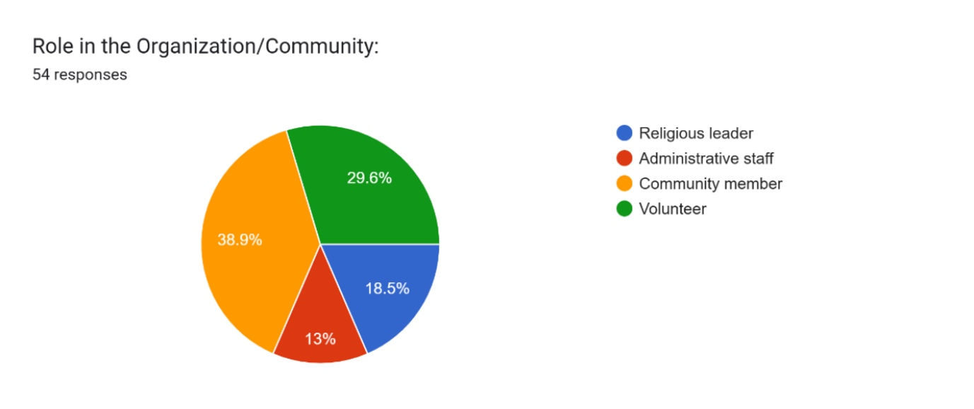

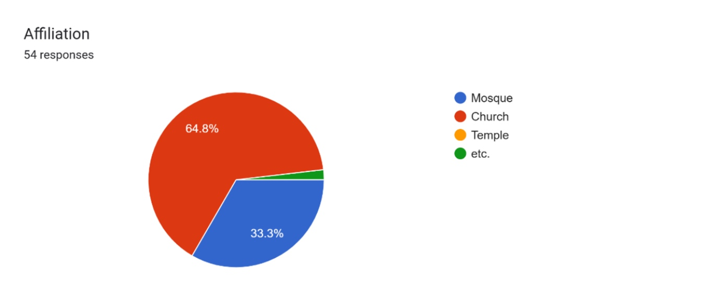

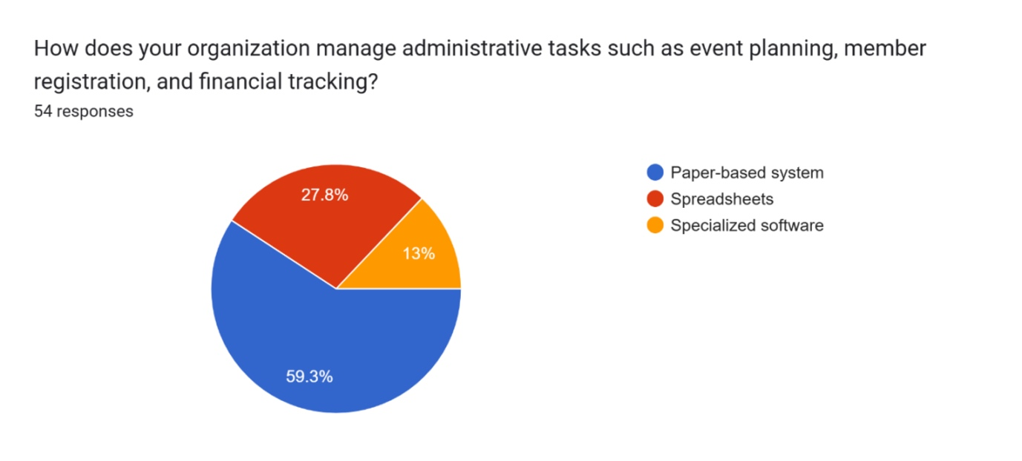

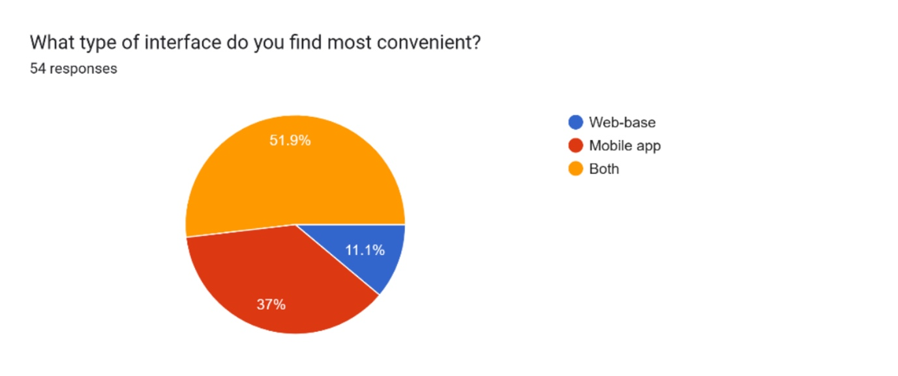

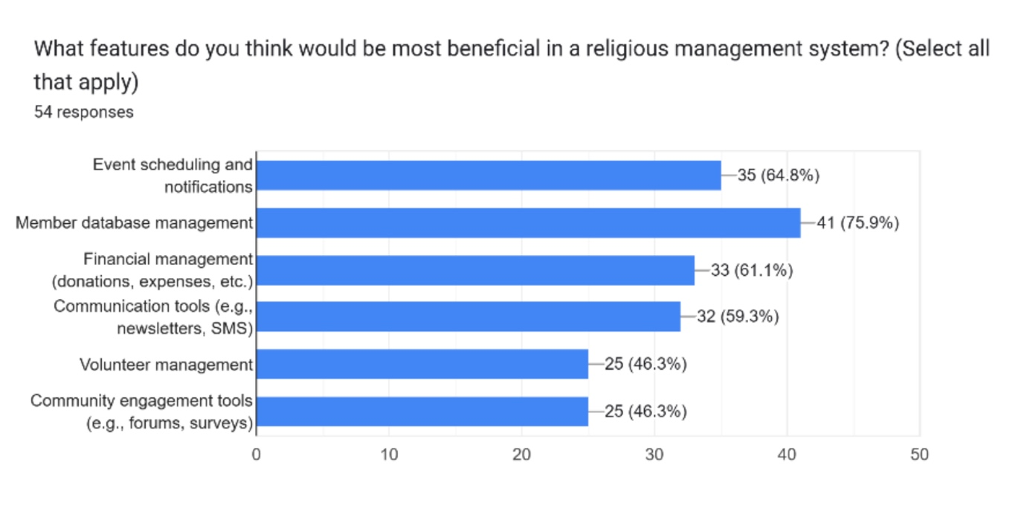

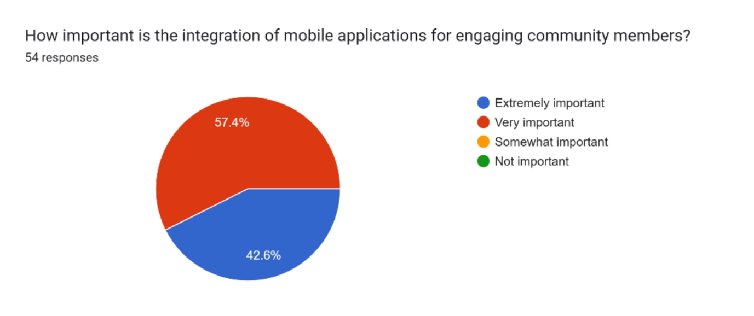

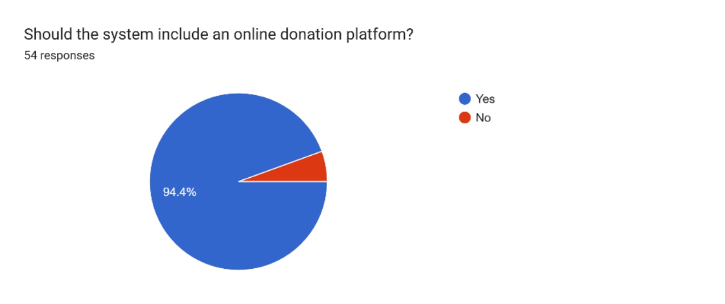

**3. User Manual**

**Application Usage Requirements:**

The user manual give assistance and teaches users on how to use the developed system. In other to use the services provided by the application, the user must have the following:

1. A computer that supports input devices (E.g., Mouse, touch pad, keyboard amongst others)
2. Any recent version of web browsers like (Google Chrome, Firefox etc.).

**Getting started with using the system**

The system is platform agnostic: any platform can be used to access the services provided by the system.

1. Open the project in an IDE like (Intelli J IDEA, Visual Studio Code), Start MySQL Workbench server.
2. For the backend, start the API
3. For the front, type: **npm run dev**
4. Enter into the address bar the following URL **(http://localhost:3000)** and hit enter
5. On the homepage, affiliate members can click the Affiliate member button on the top navigation bar to access the login

Provide the correct user’s name and password to access the member dashboard.